

**WOPENGLISH**

**8. SINIFLAR - KAZANIM TESTİ 6**

**A. Choose the best choice. (20x4) 80**

1. **What is the word for the blank?**

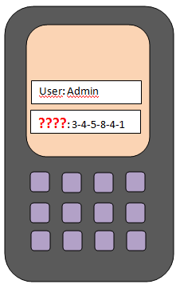

I forgot my________ and can’t log on my account.

1. attachment
2. password
3. comment
4. wireless
5. **What do the photos mean?**

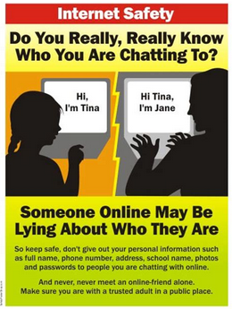

1. Don’t download files from all sites
2. Don’t open every mail attachments
3. Be careful with what you share
4. Don’t meet your online friends in person
5. ***What do you do if you like building model planes?***
6. you can follow related Vlogs
7. you make face to face communication
8. you check emails once a day
9. you create online identities
10. ***Which choice is correct according to the diagram?***

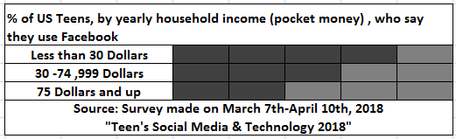

1. Lower income teens use Facebook more
2. Rich teens get less money from their family
3. Most teen facebook users get a lot of money
4. Only rich teens use facebook
5. ***Imagine that you have an internet connection problem.You see that some of the lights on your modem are off.You call the customer service. What do you say?***
6. I have a cable modem and I want to replace it with a wireless one.
7. I can’t connect to the net and some lights are off on my modem.
8. I don’t prefer using a wireless modem because I use a desktop.
9. I want to buy new modem lights because some of them are off.
10. **“You need a tool for making it possible to listen to music on the computer and the radio etc…”**

**So what is the tool you need**?



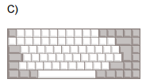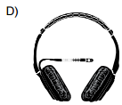

1. **Which one is a con of internet and social media?**
2. You search information
3. You can connect your friends easily
4. Some people pretend to be younger
5. You save time

**Answer the question 8 according to the diagram below.**

**8) Which sentence is NOT correct?**

1. Instagram is more popular than twitter.
2. Snapchat is as popular as Instagram in 2015
3. Facebook is the most popular.
4. Linkedin is very popular.

**Answer 9th and 10th questions using the survey below.**

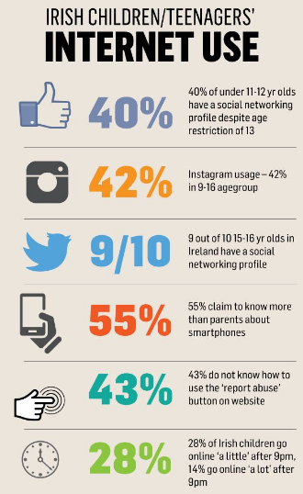

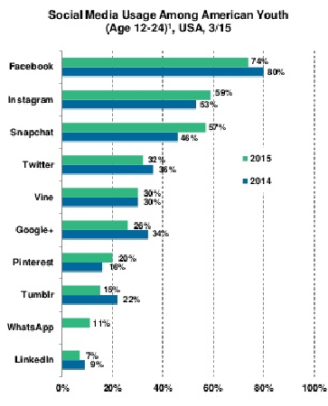

**9) Which one is correct ?**

**A)** All children use instagram

**B)** More than 50 percent of the children know more about smart phones than parents.

**C)** 50 percent of children know how to use “report abuse” button on website

**D)** Irish children stop going online before 9. o’clock.

**10) Which one is false ?**

**A)** There is an age restriction for social media

**B)** 9 out of 10 of 15-16 years in Ireland have a social media networking account

**C)** 14 percent go online a lot after 9 pm.

**D)** 55 percent of parents are very good at smartphones