**WOPENGLISH**

**7. SINIFLAR - KAZANIM TESTİ 7**



***1) Which one is NOT an air sport?***

**A)** paragliding

**B)** skydiving

**C)** hangliding

**D)** kayaking

***2) Which one is NOT an item used in a water sport?***

1. paddle
2. torch
3. goggles
4. wetsuit

**Answer the 3rd, 4th and 5th questions according to the table.**

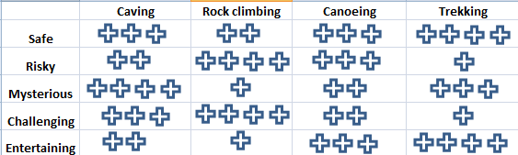

***3) Which choice is correct according to the table?***

1. Canoeing is safer than trekking
2. Rock climbing is riskier than caving
3. Rock climbing is more entertaining than caving
4. Canoeing is more challenging than trekking.
5. ***Which choice is wrong according to the table?***
6. Caving is less mysterious than trekking
7. Canoeing is more mysterious than rock climbing
8. Caving is riskier than trekking
9. Caving is more challenging than canoeing.
10. ***Which choice is correct according to the table?***
11. Caving is safer than trekking.
12. Trekking is riskier than caving
13. Trekking is less mysterious than caving
14. Caving is less challenging than trekking
15. ***“Which of the choices below may be main reason if you can’t organize your life effectively”***



**A)** You may keep in touch with your friends.

**B)** You may have problems with your internet connection.

**C)** You may have many devices to connect to the internet.

**D)** You may be spending too much time on the internet

1. **“My sister …….. sleep at night and plays computer games all night after my parents sleeps, but I don’t do that. I play games ….… ”**
2. confirms - effectively
3. always - functionally
4. pretends to - moderately
5. ignores - addictively
6. **Which one is NOT a sentence of clarification?**

**A)** What do you think about the internet?

**B)** Can you explain it more, please?

**C)** Can you explain what it means?

**D)** What do you mean?

**9) Which sentence of preference is incorrect?**

**A)** I would rather do outdoor sports than indoor sports.

**B)** I prefer waterskiing to kayakking

**C)** I would not rather do caving

**D)** I don’t prefer extreme sports

**10) Which sentence is NOT correct?**

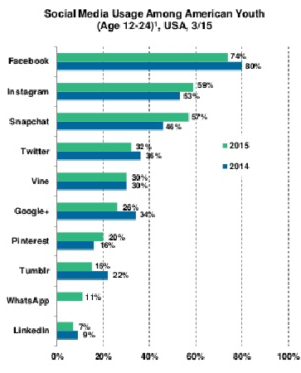

**A)** Instagram is more popular than twitter.

**B)** Snapchat is as popular as Instagram in 2015

**C)** Facebook is the most popular.

**D)** Linkedin is very popular.