**WOPENGLISH**

**7. SINIFLAR - KAZANIM TESTİ 7**



***1) Which one is NOT an air sport?***

***A)*** *paragliding*

***B)*** *skydiving*

***C)*** *hangliding*

***D)*** *kayaking*

***2) Which one is NOT an item used in a water sport?***

1. *paddle*
2. *torch*
3. *goggles*
4. *wetsuit*

***Answer the 3rd, 4th and 5th questions according to the table.***

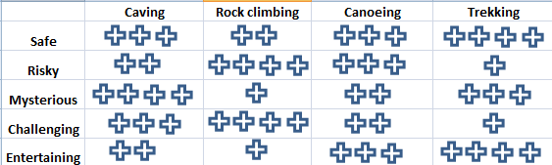

***3) Which choice is correct according to the table?***

1. *Canoeing is safer than trekking*
2. *Rock climbing is riskier than caving*
3. *Rock climbing is more entertaining than caving*
4. *Canoeing is more challenging than trekking.*
5. ***Which choice is wrong according to the table?***
6. *Caving is less mysterious than trekking*
7. *Canoeing is more mysterious than rock climbing*
8. *Caving is riskier than trekking*
9. *Caving is more challenging than canoeing.*
10. ***Which choice is correct according to the table?***
11. *Caving is safer than trekking.*
12. *Trekking is riskier than caving*
13. *Trekking is less mysterious than caving*
14. *Caving is less challenging than trekking*
15. ***“Which of the choices below may be main reason if you can’t organize your life effectively”***



***A)*** *You may keep in touch with your friends.*

***B)*** *You may have problems with your internet connection.*

***C)*** *You may have many devices to connect to the internet.*

***D)*** *You may be spending too much time on the internet*

1. ***“My sister …….. sleep at night and plays computer games all night after my parents sleeps, but I don’t do that. I play games ….… ”***
2. *confirms - effectively*
3. *always - functionally*
4. *pretends to - moderately*
5. *ignores - addictively*
6. ***Which one is NOT a sentence of clarification?***

***A)*** *What do you think about the internet?*

***B)*** *Can you explain it more, please?*

***C)*** *Can you explain what it means?*

***D)*** *What do you mean?*

***9) Which sentence of preference is incorrect?***

***A)*** *I would rather do outdoor sports than indoor sports.*

***B)*** *I prefer waterskiing to kayakking*

***C)*** *I would not rather do caving*

***D)*** *I don’t prefer extreme sports*

***10) Which sentence is NOT correct?***

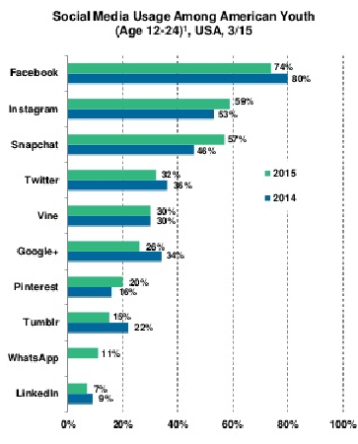

***A)*** *Instagram is more popular than twitter.*

***B)*** *Snapchat is as popular as Instagram in 2015*

***C)*** *Facebook is the most popular.*

***D)*** *Linkedin is very popular.*