

**WOPENGLISH**

**8. SINIFLAR - KAZANIM TESTİ 8**

**1) Pilots of Turkish Stars are not inexpreinced. They are _______ .**

**A)** entertaining

**B)** professional

**C)** brave

**D)** amazing

**2) Which match is INCORRECT?**

1. take - risks
2. backup - camp
3. adrenaline - seeker
4. acrobatic - movements

**Answer the 3rd and 4th questions according to the table.**

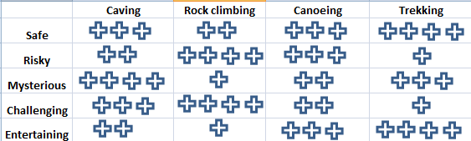

**3) Which choice is correct according to the table?**

1. Trekking is riskier than rock climbing
2. Rock climbing is is safer than trekking
3. Trekking is more mysterious than rock climbing
4. Rock climbing is more challenging than trekking.
5. **Which choice is wrong according to the table?**
6. Canoeing is riskier than caving
7. Canoeing is safer than caving
8. Canoeing is less mysterious than caving
9. Canoeing is less entertaining than caving
10. **_____ are a pair of equipment that hang-gliders need to fly.**
11. experience
12. aim
13. wings
14. paddles
15. **Which “adjective – comperative” match is INCORRECT ?**

**A)** bad - better

**B)** little - less

**C)** far - further

**D)** many /much - more

1. **Which comperative sentence is INCORRECT ?**
2. Sky-diving is more dangerous than rock-climbing.
3. Antalya is hotter than Istanbul
4. Riding a bike is more easier than riding a horse.
5. Kayaking is less interesting than hang-gliding

**8)** **What is the importance of Hazerfen Ahmet Çelebi’s trial of flying in Turkish history?**

**A)** He improved adventures

**B)** He improved aircraft industry in Turkey

**C)** He helped start the researches of space in Turkey

**D)** He opened the first school of aviation

**9) Which sentence shows a preference between 2 extreme sports?**

**A)** I don’t prefer wind-surfing

**B)** I prefer waterskiing to skating

**C)** I would not rather do kayaking

**D)** I would rather do hang-gliding than sky-diving.

**10) Which “V1-V2” match is INCORRECT?**

1. choose – chose
2. think – taught
3. sing –sang
4. steal - stole