

**WOPENGLISH**

**7. SINIFLAR - KAZANIM TESTİ 9-KEY**

1. **Ken: My dad is a baker. He - - - - .**

a) works in a restaurant

b) sells bread,muffins and cookies

c) treats ill people

d) works in a shoe shop

1. **My fater is a florist. He ……. .**

a) works in a restaurant b) repairs cars c) sells flowers d) cleans the floors

1. **Betty: Where were you last weekend?**

**Sue: I was at the - - - - . I bought a parrot.**

a) pet shop b) cinema c) boutique d) bookstore

1. **Kaan: I need some meat.**

**Selim: - - - -**

a) Let’s go to a coffee shop!

b) Why don’t you go to an art gallery?

c) You should go to a butcher’s.

d) How about going to a pharmacy?

1. **Jane: I will go to the shopping mall on Sunday. I will buy a new dress for my birthday party. - - - - ?**

**Tim: Sure. I also need new trousers.**

a) Will you join me

b) Can I help you

c) Do you like going to zoo

d) What did you like last weekend

**6. Joe: Where are you going?**

**Kate: I am going to the bookstore. I will buy - - - - .**

a) new trainers

b) some bread and muffins

c) some medicine

d) some magazines

**7. You must call - - - - if you witness a crime.**

a) fire station b) police station c) post office d) bank

**8. One of your friends wants you to do grocery shopping for him but you are so busy .So you say him; ---**

a) I love going shopping! Where is the shopping list?

b) I am sorry I am in a hurry. I must go to the library.

c) Of course, I do. What do you need?

d) Don’t worry! I will do it for you!

**9.**

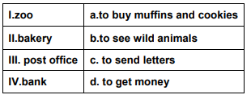

**Yukarıdaki tablonun doğru eşlenişi aşağıdakilerden hangisidir?**

a) I.c – II.a – III.d – IV.b

b) I.b – II.a – III.c- IV.d

c) I.c – II.d –III.c- IV.b

d) I.b – II.a –III.d – IV.c

**10. “Last weekend, I went to the greengrocer, pharmacy and shoe shop.” Yukarıdaki cümlede bahsedilmeyen görsel aşağıdakilerden hangisidir?**

a) 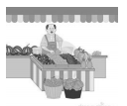 b) 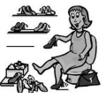

c) 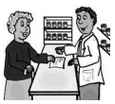 d) 