**WOPENGLISH**

**9. SINIFLAR - KAZANIM TESTİ 7**



1. **In the desert, The weather is a problem, too. During the day-time, it is hot, but you can’t take off your ____ or ____ because the sun shines directly on you.**
2. scarf – long sleeved shirt
3. journey – get into sand
4. stockings – check-patterned
5. slippers – get into the sea
6. water - drink
7. **Which one is incorrect If you live on the edge?**
8. You work under heavy conditions
9. You need some unusual abilities
10. You needn’t speak different languages.
11. You are able to survive without food
12. You are able to repair your car by yourself
13. **“There is a heavy rain and you can see a land slide down the hill.”**

**So**, **what should you do?**

1. You should stay at the river banks
2. You should sit under a tree
3. You should wait near an electrical wire
4. You should wait in front of the door and take a video
5. You should take shelter under a solid piece of furniture

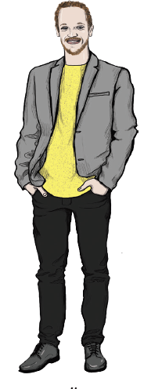

1. **Which information is incorrect?**
2. He is thin
3. He has only beard
4. He has short hair
5. He has an oval face
6. He is tall
7. **What is wrong for a wild life photographer?**
8. She can swim with sharks
9. She can take a fast photo in wildlife park
10. She can speak at least two languages to give While I was setting off, my mum called me.
11. She can save animals from tall trees
12. She can swim with dolphins

