

**WOPENGLISH**

**9. SINIFLAR - KAZANIM TESTİ-KEY**

1. **The weather________ rainy and _______ . So we go to a picnic.**

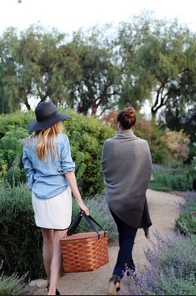

1. has – can’t
2. isn’t – can’t
3. is - can
4. isn’t - can
5. doesn’t - can
6. **Turkey is a tourist paradise. It has got a lot of tourist _________ like fairy chimneys in Capadocia.**
7. dishes
8. people
9. cities
10. attractions
11. accidents
12. **We are in Cappadocia now. We are ______ the beauty of the view.**

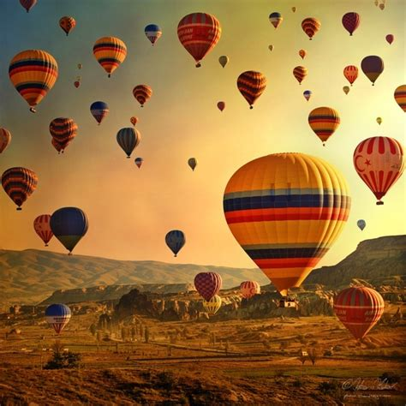

1. damaging
2. admiring
3. visiting
4. destroying
5. descovering
6. **The list of the seven ______ of the world is old. We must make a new list.**

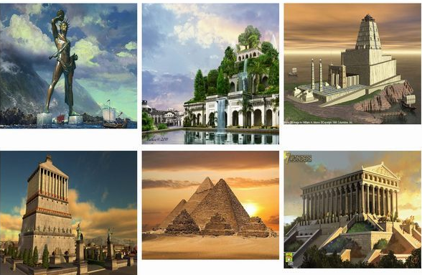**A)** remains **B)** stories **C)** wonders **D)** voices **E)** victory

1. **The king wanted to build a _____ in his wife’s memory but he died only two months after her.**

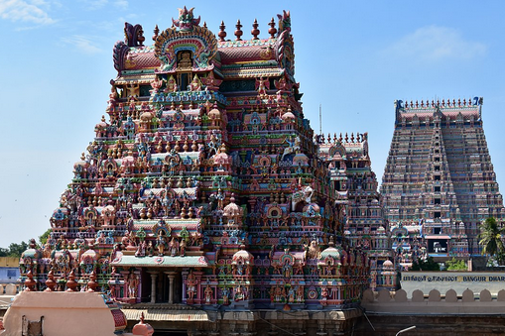

A) remain

B) stone

C) island

D) roof

E) temple