**Choose the correct answer.**

1. **Mum:** Do you get on well with Joe?

**David:** No, I don’t. ___________________

1. He never supports me.
2. I can always count on him.
3. We have a lot in common.
4. He’s really cool.
5. **Sue:** Are you busy this afternoon?

**Jenny:** _____________. Why?

**Sue:** Our school is organizing a basketball tournament. Come and watch us.

1. Yes, I’d like to.
2. No, thanks. I feel bad.
3. No, not at all.
4. Sure, it sounds fun.
5. **Kevin:** Would you like some cookies?

**Mary:** No, thanks. _______ .

1. They are my favorite cookies.
2. I’m full.
3. They look tasty.
4. Yeah, why not?
5. **Sam:** How about watching The Angry Birds Movie? They say it’s great.

**Emma:** Do we have another choice? ____________________

**Sam:** What about Miss Peregrine’s Home for Peculiar Children?It’s an adventure film.

**Emma:** That’s better. Let’s watch it.

1. It’s one of my favorite films.
2. I’m not really into animated movies.
3. That would be great.
4. I think I’ll likeit a lot.Teacher’s Copy
5. **Carol:** I’m not going to attend Katy’s slumber party because_________________.
6. I’m not doing anything then.
7. I have to study.
8. I like her parties a lot.
9. my best friends are coming, too.
10. **Tim:** I’d like to see you on Saturday, but ________________
11. my cousin is coming from Paris.
12. tell me when you’re going to meet.
13. I enjoy being with you.
14. I don’t have any plans.
15. **Mary:** I’m going to have a pajama party and ______________
16. come over to my place at 7.
17. don’t shareit with my friends.
18. invite all of my friends.
19. can’t go for a walk now.
20. **Choose the correct answer.**

***I. How often do you try one?***

***II. Hardly ever. Mum says they are dangerous.***

***III. Yes, of course. I think they are fun.***

***IV. Are you into unusual sports***

1. I/ III/ IV/ II
2. IV/ II/ I/ III
3. IV/III/I/ II
4. II/ I/ IV/ III
5. I.Really? I think this is quite impressive.

II. Also, I can’t stand jazz music.

III.Let’s go to the jazz concert on Saturday.

IV.Thanks, but I prefer being with my family on Saturdays.

1. III/ II/ IV/ I
2. III/ IV/ I/ II
3. II/ I / III/ IV
4. II/ III/ I/ IV
5. **Examine the table and choose the correct answer.**

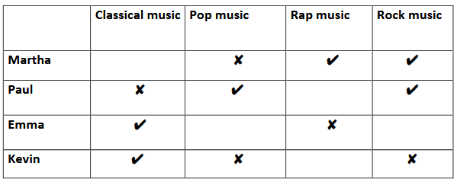

1. Martha and Kevin don’t like rock music.
2. Paul likes classical music but not pop music.
3. Martha likes rap music but Emma doesn’t.
4. Emma likes rap music but not classical music.
5. 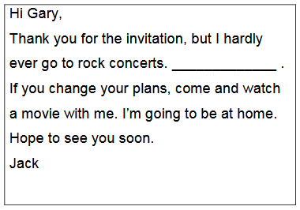
6. I think they are unbearable.
7. I prefer watching rock concerts live.
8. Tell me when it starts.
9. This is a terrific idea.

**Betty:** _______________________

**Laura:** Once in a while. I usually watch movies, hang out with friends, do sports and shop.

1. How often do you do go to concerts ?
2. How do you spend your weekends ?
3. What do you usually do in your free time?
4. When do you meet your friends?

**Nelly:** Serena Williams is playing against Venus Williams on Saturday. Are you going to watch the match?

**Nick:** I think it’s going to be terrific. But to be honest, ____________ It’s my favorite game.

1. That’s very impressive.
2. I can’t stand it .
3. Iprefer soccer.
4. That’s fine with me.

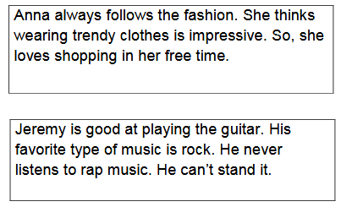

1. Anna ________.
2. prefers wearing casual clothes
3. thinks it’s ridiculous to follow the fashion
4. never spends time buying clothes
5. thinks wearing trendy clothes is awesome.
6. Jeremy ________.
7. can’t play the guitar
8. thinks rap music is unbearable
9. hardly ever listens to rock music
10. likes spending time with his friends
11. ***“ I usually roast chicken.”* ifadesini anlatan görsel aşağıdakilerden hangisidir?**

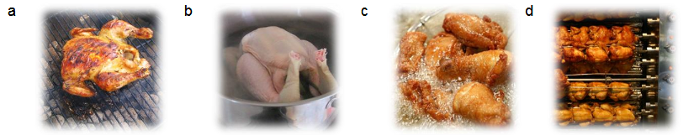

1. ***“Peel the carrots after washing them.”* ifadesini anlatan görsel aşağıdakilerden hangisidir?**

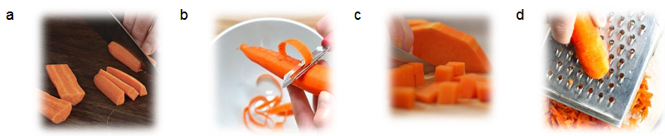

1. ***“Pour the mixture into the pan.”* ifadesini anlatan görsel aşağıdakilerden hangisidir?**

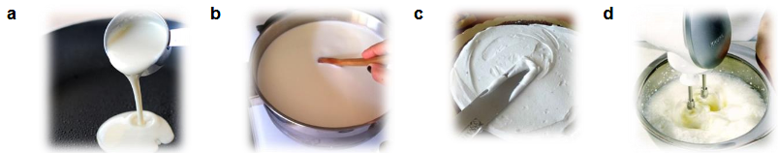

1. ***“Knead the dough.”* ifadesini anlatan görsel aşağıdakilerden hangisidir?**

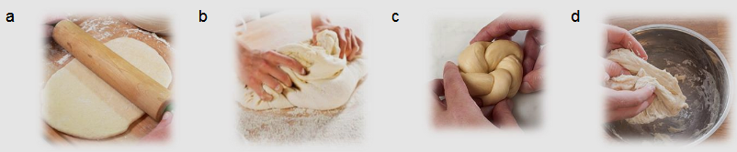

1. **Examine the chart about teens’ communication choices. Choose the correct answer.**

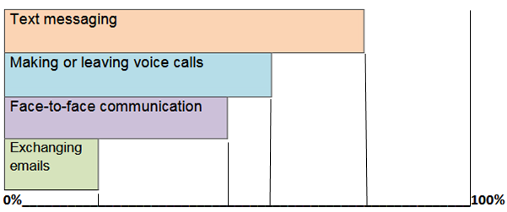

**20) Teens ________________________________.**

1. are not interested in exchanging emails
2. hardly ever send text messages
3. prefer making or leaving voice calls to texting
4. would rather socialize with their friends in person than text them.

***J1) Your brother’s friend, Joe,is calling to speak to your brother, but your bother is busy.***

**What do you say?**

1. Hold on. I’ll get him.
2. I’m afraid he’s not available.
3. Fine, thanks.
4. I’ll put you through.

***J2) You’re calling your friend Mary. Her mother answers.***

**What do you say?**

1. Could you please repeat?
2. Could I leave a message?
3. Could you ask Mary to call me?
4. Could I speak to Mary, please?

J3) A friend is online and wants your address and phone number. Which one is the best thing to do?

1. Give it directly. There is nothing to scare.
2. Ask mother and give it.
3. Say “ you can give it tomorrow at school”
4. Write it to you profile