**2019-2020 EĞİTİM ÖĞRETİM YILI**

**………… ORTAOKULU**

**8. SINIFLAR 1.DÖNEM 1. İNGİLİZCE YAZILI SINAVI (B)**

**Name-Surname:**

**____________________**

**Class: __-__ Number: ____**

**Mark: _______**

**Signiture:___________**

**A. Choose the best choice. (20x3) 60**

**1) How about _____ dinner?**

**A)** have **B)** to have

**C)** having **D)** is having

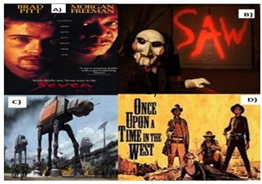

**2) I ‘d rather ……… eggs than ……… eggs.**

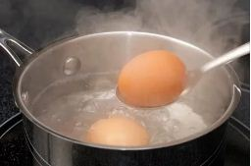

**A)** boiling - frying

**B)** boiling - fry

**C)** frying- boil

**D)** boil - fry

**3)** **A: ………………………………**

**B: He likes seeing a movie and hang out with friends.**

**A)** Does your uncle like watching movies?

**B)** Does your uncle hang out with his friends?

**C)** When does your uncle spend time with her friends?

**D)** What does your uncle like doing in his spare time?

**4)** A: What is James like?

B: He always helps people. He is …. person.

**A)** reliable **B)** hardworking  
 **C)** handsome **D)** supportive

**5) You want to agree your friends invitation.**

**What would you say to him/her?**

**A)** Yes, that would be great, but I am tired.

**B)** Well, I don’t feel like walking.

**C)** I’d love to, thanks.

**D)** I’m sorry but I can’t

**6) I can’t stand tecno or beatbox, but I’m fond of folk music ....**

**A)** I find it impressive. **B)** It relaxes me.

**C)** Folk music is ridiculous **D)** It is not harmonic.

**7)** **Ahmet:** The weather is very hot.

**Ayşe :** ……….. eat ice-cream?

**Ahmet:** Oh, thank you.

**Which answer is incorrect for the blank?**

**A)** How about **B)** Let’s

**C)** Shall we **D)** Why don’t we

**8) Which movie type given in the dialogue is not shown in the pictures?**

**Behlül:** What kind of movie do you like?

**Bihter :** I like thriller, sci-fi and horror

D)

**9) Aslı :** Will you come to my party?

**Kerem :** …..

**Which one is an excuse for Aslı’s question?**

1. Yes, I’d love to. What time is it?
2. Of couse. That sounds awesome.
3. I’d love to, but I have guests
4. I’m sorry but I can’t

**\*\*Answer the 10th and 11th questions from the table below.**

**10) Which sentence is correct according to the table?**

[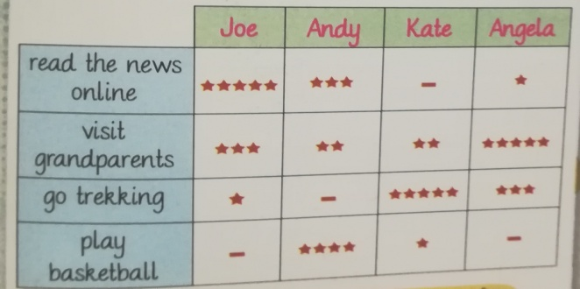](http://www.cliparthut.com/geese-playing-golf-clipart.html)

**A)** Joe always visits his grandparents.

**B)** Kate seldom plays basketball

**C)** Angela never reads newspaper

**D)** Andy often goes to trekking

**11) Which preference is correct according to the table?**

**A)** Andy prefers reading news to playing basketball.

**B)** Joe prefers playing basketball to reading news online

**C)** Angela prefers visiting grand parents to going trekking

**D)** Kate prefers reading the news online to playing basketball

**12) Miley Cyrus is the singer. I mean she is …**

**A)** thedrummer

**B)** the band

**C)** the keyboard

**D)** the performer

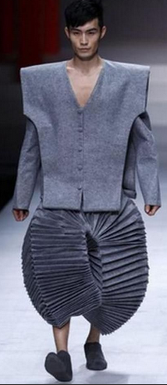**13) Sam looks very ………**

**with these clothes.**

**A)** snob

**B)** impressive

**C)** ridiculous

**D)** serious

**14**) **Segio: ……… ?**

**Wilma: Maths. I find it so logical.**

**A)** What is your favourite school subject?

**B)** What type of music do you prefer?

**C)** Hof often do you go to the concerts?

**D)** How do you feel at concerts?

**15) Serhat: Do you like classical music?**

**Aysel: ….. because it’s boring.**

**A)** Not a bad idea.

**B)** I can’t stand it.

**C)** Of course.

**D)** That sounds good.

**16) Where do you roast chicken?**

**A)** pot

**B)** sauce pan

**C)** oven

**D)** grater

**17) Write the words below in the blanks orderly.**

**In the morning, ….. I wash my face. ….. I have my breakfast. ….. I meet my friends at the bus stop. ….. I arrive at school right on time.**

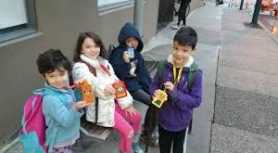

**1)** Then

**2)** First

**3)** Finally

**4)** After that

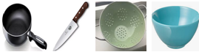

**A)** 1-2-3-4 **B)** 1-2-4-3

**C)** 2-1-3-4 **D)** 2-1-4-3

**18)** “I love kneading the dough. It is great fun for me.”

Which picture shows the activity above?

1. 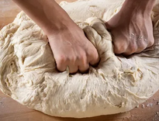 **B)** 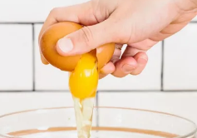

**C) 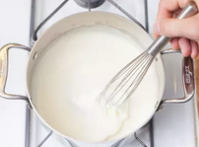 D)** 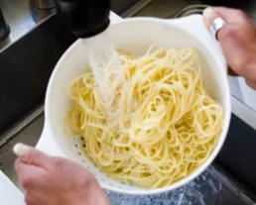

1. **“I am crazy about Heavy Metal Music” means …**

**A)** I am keen on Heavy Metal music

**B)** I am fond of Heavy Metal music.

**C)** I like Heavy Metal music.

**D)** I enjoy Heavy Metal music.

**20) Which pictures show the tyeps of proccesses below?**

**“drained - thinned - marinated - seasoned**

1. 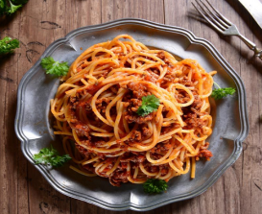 **2)** 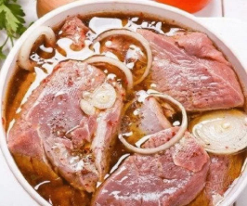
2. 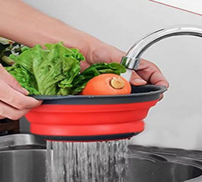 **4)** 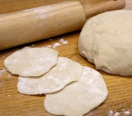
3. **1-Drained / 2-Thinned / 3-Marinated / 4-Seasoned**
4. **1-Seasoned / 2-Marinated / 3- Drained / 4-Thinned**
5. **1-Marinated / 2-Seasoned / 3-Drained / 4-Thinned**
6. **1-Thinned / 2-Seasoned / 3 –Marinated / 4- Drained**

**J1- “1-soğan , 2-makarna, 3-maydonoz, 4-sarımsak”**

1. **1-onion / 2- garlic / 3-parsley / 4- pasta**
2. **1-garlic / 2-pasta / 3-parsley / 4-onion**
3. **1-onion / 2-pasta / 3- parsley / 4-garlic**
4. **1-parsley / 2-pasta / 3-garlic / 4-parsley**

**J2) “Which one is not in the picture?”**

A) pan B) knife C) bowl D) grater

**B) Write the words for the given pictures. (15x2=30)**

|  |  |  |  |  |  |
| --- | --- | --- | --- | --- | --- |
|  | **Word:** | **Turkish Meaning:** |  | **Word:** | **Turkish Meaning:** |
| **1-** | to recommend |  | **10-** | to get high grades |  |
| **2-** | to pay attenion |  | **11-** | to attend |  |
| **3-** | to depend on |  | **12-** | impressive |  |
| **4-** | to insult |  | **13-** | folk music |  |
| **5-** | to slice |  | **14-** | attractive |  |
| **6-** | to dice |  | **15-** | unbearable |  |
| **7-** | to enjoy |  | **J3-** | invitation |  |
| **8-** | to chop |  | **J4-** | relationship |  |
| **9-** | to have dinner |  | **J5-** | reunion |  |

**C) Circle the correct choice. (5x2) 10**

|  |
| --- |
| **1.** Shall we **(dance / dancing)** together?  **2.** Let’s **(drink / drinking)** something cold?  **3.**What about **(watch / watching)** a cartoon on TV?  **4.**How about **(play / playing)** table tennis?  **5.** Would you like to **(go / going)** to the cinema with me? |