- Fill in the blanks “countries” and “nationalities” (10x1) 10
Nationalities

_______________
Greek
_______________
Chinese
_______________
German
_______________
Australian
_______________
Italian

Countries

France
_____________
Tu r ke y
_____________
Britain
_____________
Spain
_____________
Portugal
_____________

- Put the phrases in the correct order. (5x3)15
- has / a desk/ Mark / in his room / got.
___________________________________________
- not / Emily / got/ brown hair / has.
___________________________________________
- you / got / in France / a friend / have ?
___________________________________________
- got / the rabbit / has / small eyes ?
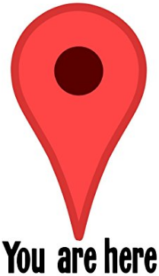
___________________________________________
- got / a big house / have / the Smiths ?
___________________________________________

- Complete the sentences with the correct possessive adjective “my,your,his,her,its,our, their” (5x2)10
- This is my dog. ______ name is Lassie.
- We’ve got umbrellas. ________ umbrellas are big.
- Ayşe has a bike. _______ bike is red .
- Mr. Stevans is a taxi driver. ______ taxi is yellow.
- I am from Spain, but _______ cousins are English.

- Write “directions” for the place. Use the map given (5x3)15
- How can I go to Korean restaurant?
_________________________________
_________________________________
__________________________________

- How can I go to club?
_________________________________
_________________________________
_________________________________
- How can I go to Park?
_________________________________
_________________________________
_________________________________
- How can I go to Shopping center?
_________________________________
_________________________________
_________________________________
- How can I go to the art gallery?
_________________________________
_________________________________
_________________________________

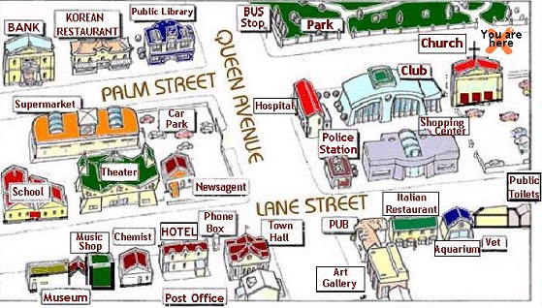

- Find the pairs in the word box and complete the chart. (5x3) 15
brother daughter father son
husband mother sister aunt
wife uncle

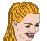 | 
_______________  _______________  _______________  _______________  _______________ | _______________  _______________  _______________  _______________  _______________

- Complete the sentences with the correct question words. (There is one extra word.) (5x2) 10
How What Where
Who When Which

- A: __________ are these ? B: They are bags.
- A: __________ is your bike? B: The red one.
- A: _________ is Max from? B: He is from Italy
- A: _________ are your parents? B: Good.
- A: _________ is your cousin? B: Kevin.

- Match the sentences to make meaningful answers. (5x2) 10
Yes, there are a lot of books in it.
That’s strange! They are in Spain.
It’s rainy and windy.
I can speak German too.
I’m fine. How are you?

I can speak German. What about you?
What’s up, Mike?
Our school library is very big.
The Wilsons’ front door is open
What’s the weather like in UK?

- (__) | - (__) | - (__) | - (__) | - (__)

- Write the meanings of the words in Turkish.
(15x1)15
- Builder: _________________________
- Engineer: ________________________
- Electrician: _______________________
- Flight attendant: ___________________
- Lawyer: __________________________
- Country: _________________________
- Aunt: ____________________________
- Rainy: ___________________________
- Windy: __________________________
- Hair dresser:________________________
- Farmer: ____________________________
- Library: ___________________________
- School uniform: ____________________
- Yard: _____________________________
- Around the world: __________________

https://wopenglish.com

