Name-Surname:
__________________
Class: __-__ Number: ____
2019-2020 EĞİTİM ÖĞRETİM YILI
................... LİSESİ
10-A SINIFI 1.DÖNEM 1. İNGİLİZCE YAZILI SINAVI
- Write the Turkish meanings of the words below. (There are 2 joker words) (20x1) 20
- Information Technology: _______________
- Physical Education: ____________________
- Unusual:_____________________________
- To grow up: __________________________
- Comment: ___________________________
- Local: ______________________________
- On my own: __________________________
- Suitable: ____________________________
- Nephew: ____________________________
- Generation: __________________________
- To lend a hand: _______________________
- To return: ____________________________
- Daughter: ____________________________
- Relation:_____________________________
- Expect: _____________________________
- To have a nap: ________________________
- Niece: ______________________________
- To participate: ________________________
- To put on a play: ______________________
- Flat: ________________________________
J1) Spare time: :__________________________
J2) Homeless: ___________________________

Read the text.
(Posted by Talya, Turkey)
Hey there! My name is Talya. I am 15 years old and I attend an international school in Istanbul, Turkey. There are over 500 hundred pupils from about 40 countries at my school. We have got a lot of different subjects and we have to work hard, but I enjoy it very much because we have excellent teachers. Besides, my classmates are very friendly. Our timetable are full of all the usual subjects like Maths and History. But we also study a lot of different foreign languages. My favourite one is Italian. When I finish my studies, I want to travel around Italy because I love it.

(Posted by Edmund, UK)
My school is unusual too. We make our time tables on our own and choose the lessons we

want to study. It’s amazing. Everyone Works really hard because they love their lessons. I spend most of my school day in the computer lab having IT lessons. I also take part in a lot of interesting technology projects with my friends. When I leave school, I want to create new computer programmes.

- Now, Write (T) for true and (F) for false sentences. (10x2) 20

- Talya learns more than one foreign language at school. (__)
- Most students at Talya’s school are Turkish. (__)
- Talya’s teachers are very good. (__)
- Talya’s favourite language is French. (__)
- There are only 500 pupils in Talya’s school. (__)
- Edmund’s school is very different from Talya’s school. (__)
- Edmund has no idea about what to do when he grows up. (__)
- Edmund takes part in technology projects every month. (__)
- Teachers give time tables at Edmund’s school. (__)
- Edmund wants to create computer programmes in the future. (__)

- Match the synonyms of the words given. (5x2) 10

A | Excellent |  |  | 1 | Join
B | Find out |  |  | 2 | Fix
C | Take part in |  |  | 3 | Learn
D | Important |  |  | 4 | Perfect
E | Solve |  |  | 5 | Serious

- Look at the family tree and write “the correct family word” to the blank. (There is one joker word) (5x2) 10

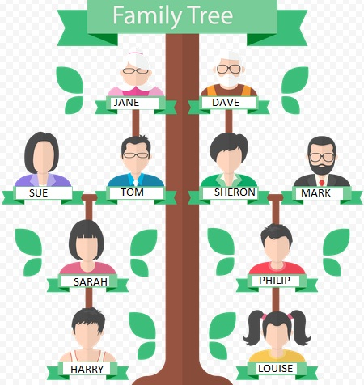

- Harry is Philip’s _____________________ .
- Louise is Sarah’s _____________________ .
- Jane is Harry’s ______________________ .
- Tom is Philip’s ______________________ .
- Sarah is Sharon’s ____________________ .
J1. Philip is Tom’s ______________________ .

- Fill in the blanks with “the correct form of the verb”. Use “Frequency adverb” at correct place! (5x2) 10

- Sally _________________________________ (lend/always) a hand to her old mother for the housework.
- Both of my sibblings ___________________ (look like) my mother. They have green eyes like mom.
- Pall _________________________________ (always/return) the books late to the library.
- Helen _______________________________ (rarely/feed) her fish.
- Tom and I ___________________________ ( be/always) busy at work. They go home late at night.

- Put “the present continuous sentences” into the correct order. (5x2) 10
- with Patricia / now / Jeff / dancing / is.
____________________________________________________________________
- my exam/ am /right now /studying /for /I
____________________________________________________________________
- writing / Linda and I / a letter / are / now. __________________________________ __________________________________
- not / driving / his father’s car / is / Blake / these days. ________________________ __________________________________
- parents / my / preparing / now / are / dinner. __________________________________ __________________________________

- Write “Simple” (for Present Simple) or “ Cont” (for Present continuous) for the time expressions (5x2) 10

- Every year: _____________________
- Once a month: __________________
- This Sunday : __________________
- On Fridays: ____________________
- At the moment: _________________

- Fill in the blanks with “ will V1” or “am/is/are going to V1” ( 5x2) 10

- A: Hey.. Look at those dirty dishes!
B: Don’t worry. I ___________________ (help) you wash them.

- A: The dog looks hungry.
B: I know. I __________________ (feed) it right now.

- A: What do you think about Joe’s party this evening?
B: I don’t know, but I think I _______________ (join) .
- Today is Sunday, so I ____________ ___________________ (sleep) late as usual.

- Be careful with your hand. The glass is very hot. You ______________________ (burn) it.

