**2021-2022 EĞİTİM ÖĞRETİM YILI**

**…………. ORTAOKULU**

**8. SINIFLAR 1.DÖNEM 1. İNGİLİZCE YAZILI SINAVI**

**Name-Surname:**

**____________________**

**Class: __-__ Number: ____**

**Mark: _______**

**A. Choose the best choice. (20x3) 60**

**1) I ‘d rather ……… eggs than ……… eggs.**

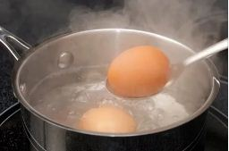

**A)** boiling - frying

**B)** boiling - fry

**C)** frying- boil

**D)** boil - fry

**2)** **A: ………………………………**

**B: He likes seeing a movie and hang out with friends.**

**A)** Does your uncle like watching movies?

**B)** Does your uncle hang out with his friends?

**C)** When does your uncle spend time with her friends?

**D)** What does your uncle like doing in his spare time?

**3)** A: What is James like?

B: He always helps people. He is …. person.

**A)** reliable **B)** hardworking  
 **C)** handsome **D)** supportive

**4) You want to agree your friends invitation.**

**What would you say to him/her?**

**A)** Yes, that would be great, but I am tired.

**B)** Well, I don’t feel like walking.

**C)** I’d love to, thanks.

**D)** I’m sorry but I can’t

**5)** **Ahmet:** The weather is very hot.

**Ayşe :** ……….. eat ice-cream?

**Ahmet:** Oh, thank you.

**Which answer is incorrect for the blank?**

**A)** How about **B)** Let’s

**C)** Shall we **D)** Why don’t we

**6) Which movie type given in the dialogue is NOT in the pictures?**

**Betül:** What kind of movie do you like?

**Bihter :** I like thriller, sci-fi and horror

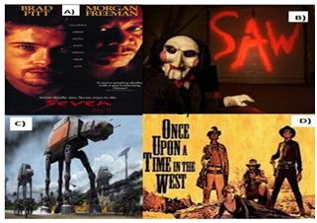

D)

**(Jokers of Part A can be used only for Part A)**

**7) I can’t stand tecno or beatbox, but I’m fond of folk music ....**

**A)** I find it impressive. **B)** It relaxes me.

**C)** Folk music is ridiculous **D)** It is not harmonic.

**8) Aslı :** Will you come to my party?

**Kerem :** …..

**Which one is an excuse for Aslı’s question?**

1. Yes, I’d love to. What time is it?
2. Of couse. That sounds awesome.
3. I’d love to, but I have guests
4. I’m sorry but I can’t

**\*\*Answer the 9th and 10th questions from the table below.**

**9) Which sentence is correct according to the table?**

[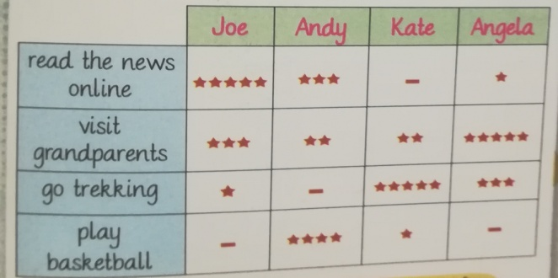](http://www.cliparthut.com/geese-playing-golf-clipart.html)

**A)** Joe always visits his grandparents.

**B)** Kate seldom plays basketball

**C)** Angela never reads newspaper

**D)** Andy often goes to trekking

**10) Which preference is correct according to the table?**

**A)** Andy prefers reading news to playing basketball.

**B)** Joe prefers playing basketball to reading news online

**C)** Angela prefers visiting grand parents to going trekking

**D)** Kate prefers reading the news online to playing basketball

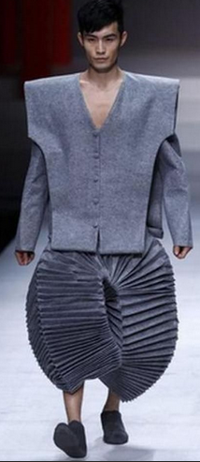**11) Sam looks very ………**

**with these clothes.**

**A)** snob

**B)** impressive

**C)** ridiculous

**D)** serious

**12**) **Sergio: ……… ?**

**Wilma: Maths. I find it so logical.**

**A)** What is your favourite school subject?

**B)** What type of music do you prefer?

**C)** Hof often do you go to the concerts?

**D)** How do you feel at concerts?

**13) Where do you roast chicken?**

**A)** pot

**B)** sauce pan

**C)** oven

**D)** grater

**14) Write the words below in the blanks orderly.**

**In the morning, ….. I wash my face. ….. I have my breakfast. ….. I meet my friends at the bus stop. ….. I arrive at school right on time.**

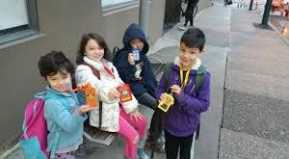

**1)** Then

**2)** First

**3)** Finally

**4)** After that

**A)** 1-2-3-4 **B)** 1-2-4-3

**C)** 2-1-3-4 **D)** 2-1-4-3

**15)** “I love kneading the dough. It is great fun for me.”

Which picture shows the activity above?

1. 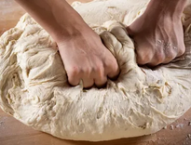 **B)** 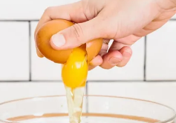

**C) 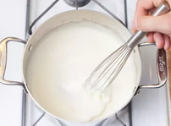 D)** 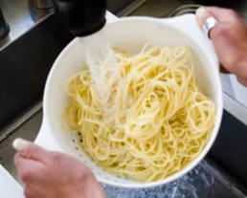

**16)** **Secretary :** Hello, Mrs. Jones speaking.

**Judy :** Hello, could I speak to Mr. Taylor, please?

**Secretary :** - - - -

**Judy :** Judy Roberts.

**Secretary :** OK, Mrs Roberts, could you hold on a moment, please?

**A)** I’ll call back later. **B)** One moment, please.

**C)** Could I ask who is calling? **D)** Could you please repeat that?

**17)** Teenagers usually use their PCs, tablets or smart phones to - - - - with their friends.

**A)** keep in touch  **B)** leave a message

**C)** hang on a minute **D)** speak face-to-face

**18) Which pictures show the tyeps of proccesses below?**

**“drained - thinned - marinated - seasoned**

1. 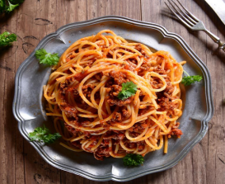 **2)** 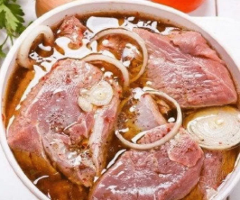
2. 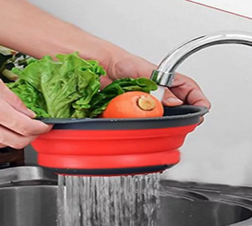 **4)** 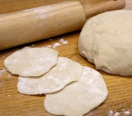
3. **1-Drained / 2-Thinned / 3-Marinated / 4-Seasoned**
4. **1-Seasoned / 2-Marinated / 3- Drained / 4-Thinned**
5. **1-Marinated / 2-Seasoned / 3-Drained / 4-Thinned**
6. **1-Thinned / 2-Seasoned / 3 –Marinated / 4- Drained**

**19) Robert :** Hello, Robert speaking.

**Sue :** Hi, Robert, it’s me Sue. Do you have any plans for tonight?

**Robert :** Sorry, Sue. I’m at the office now. Can we talk after work?

**Sue :** OK, no problem. ………………………….

**A)** Thanks for calling **B)** One moment, please

**C)** I will call you back later again **D)** I’m not available at the moment

**20) Paul :** Hello, Paul speaking.

**Sharon :** Hi, Paul. This is Sharon. Can I talk to Betty?

**Paul :** ……….. I’ll get her.

**Sharon :** Thanks, Paul.

**A)** She isn’t available now. **B)** Don’t hang up the phone.

**C)** Could you please repeat that? **D)** Can I take your name and number?

**JOKER QUESTIONS FOR THE 1st PART**

**21-J- “1-soğan 2-makarna 3-maydonoz 4-sarımsak”**

**What is the English words for the Turkish words given?**

1. **1-onion / 2- garlic / 3-parsley / 4- pasta**
2. **1-garlic / 2-pasta / 3-parsley / 4-onion**
3. **1-onion / 2-pasta / 3- parsley / 4-garlic**
4. **1-parsley / 2-pasta / 3-garlic / 4-parsley**

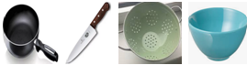**22-J- “Which one is not in the picture?”**

**A)** pan **B)** knife **C)** bowl **D)** grater

1. **“Match” the words with the “meanings”. (Jokers can be used only for this part) (20x2=40)**

|  |  |  |  |  |
| --- | --- | --- | --- | --- |
| **Vocabulary Part 1**  **(İngilizce kelimeye karşılık gelen anlamın başındaki harfi ortadaki boşluğa yazınız)** | | | | |
|  | **Word:** | **Write the matching**  **letter. (A,B,C etc)** |  | **Turkish Meaning:** |
| **23-** | to recommend |  | **A-** | **Hoşlanmak** |
| **24-** | to pay attenion |  | **B-** | **Dilim dilim kesmek** |
| **25-** | to depend on |  | **C-** | **Güvenmek** |
| **26-** | to insult |  | **D-** | **Tavsiye etmek** |
| **27-** | to slice |  | **E-** | **Önemsemek** |
| **28-** | to dice |  | **F-** | **Akşam yemeği yemek** |
| **29-** | to enjoy |  | **G-** | **Yüksek not almak** |
| **30-** | to chop |  | **H-** | **Aşağılamak** |
| **31-** | to have dinner |  | **I-** | **Kuşbaşı doğramak** |
| **32-** | to get high grades |  | **J-** | **Doğramak** |
| **Vocabulary Part 2**  **(İngilizce kelimeye karşılık gelen anlamın başındaki harfi ortadaki boşluğa yazınız)** | | | | |
|  | **Word:** | **Write the matching**  **Letter. (A,B,C etc)** |  | **Turkish Meaning:** |
| **33-** | to attend |  | **A-** | **Halk müziği** |
| **34-** | impressive |  | **B-** | **Cezbedici** |
| **35-** | folk music |  | **C-** | **Dayanılmaz** |
| **36-** | attractive |  | **D-** | **Katılmak** |
| **37-** | unbearable |  | **E-** | **Etkileyici** |
| **38-** | available |  | **F-** | **Bekletmek** |
| **39-** | hang up |  | **G-** | **Meşgul** |
| **40-** | hold on |  | **H-** | **Müsait** |
| **41-** | engaged |  | **I-** | **Bağlamak** |
| **42-** | put through |  | **J-** | **Telefonu kapatmak** |
| **Vocabulary Part 1– Joker Words.**  **(İngilizce kelimeye karşılık gelen anlamın başındaki harfi ortadaki boşluğa yazınız)** | | | | |
|  | **Word:** | **Write the matching**  **letter. (A,B,C etc)** |  | **Turkish Meaning:** |
| **43-J** | invitation |  | **A-** | **Bir araya gelme** |
| **44-J** | relationship |  | **B-** | **İlişki** |
| **45-J** | reunion |  | **C-** | **Davet** |