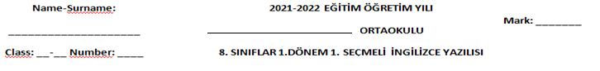

1. ***Match the words with their synonyms.(40x1) 40***

|  |  |  |  |  |  |  |  |  |
| --- | --- | --- | --- | --- | --- | --- | --- | --- |
|  |  | **Word** | **ANSWER** | **Opposite** |  | **Word** | **ANSWER** | **Opposite** |
| **PART 1** | **1.** | Buddy |  | **A-** Reliable | **6.** | Join |  | **F-** Can’t stand |
| **2.** | Count on |  | **B-** Discuss | **7.** | Get on well with |  | **G-** Share same things |
| **3.** | Laid back |  | **C-** Close friend | **8.** | Have something in common |  | **H-** Be good to eachother |
| **4.** | Trustful |  | **D-** Relaxed | **9.** | Can’t bear |  | **I-** Rarely |
| **5.** | Argue |  | **E-** Trust | **10.** | Seldom: |  | **J-** Participate |
| **PART 2** | **11.** | Nervous: |  | **A-** Would rather | **6.** | Hang out: |  | **F-** Funny |
| **12.** | Annoyed: |  | **B-** Fashionable | **7.** | Pleased: |  | **G-** Clothing |
| **13.** | Casual: |  | **C-** Angry | **8.** | Outfit |  | **H-** Upper class |
| **14.** | Stylish: |  | **D-** Everyday | **9.** | Ridiculous |  | **I-** Meet up |
| **15.** | Prefer: |  | **E-** Worried | **10.** | Snob |  | **J-** Glad |
| **PART 3** | **21.** | Aggressive |  | **A-** Barbecue | **26.** | Mix |  | **F-** Happy |
| **22.** | Bon appetite |  | **B-** Keen on | **27.** | Food |  | **G-** Cuisine |
| **23.** | Oily |  | **C-** Bad-tempered | **28.** | In the mood |  | **H-** Meal |
| **24.** | Grill |  | **D-** Enjoy your meal | **29.** | Melt |  | **I-** Stir |
| **25.** | Crazy about |  | **E-** Greasy | **30.** | Kitchen |  | **J-** Dissolve |
| **PART 4** | **31.** | Put |  | **A-** Cut the skin out | **36.** | Memo |  | **F-** Arrive |
| **32.** | Mash |  | **B-** Fall down | **37.** | Hold on |  | **G-** Engaged |
| **33.** | Peel |  | **C-** Crush | **38.** | Reach |  | **H-** Note |
| **34.** | Before |  | **D-** Place | **39.** | Busy |  | **I-** Comunicate |
| **35.** | Drop |  | **E-** Previous | **40.** | Interract |  | **J-** Wait |

1. **Write “A” for accepting , “B” for the invitations, “C” for the excuses and “D” for refusing.(10x2) 20**

|  |  |  |  |  |  |
| --- | --- | --- | --- | --- | --- |
| 41 | Yeah, I would love some. |  | 46 | I have to finish my science Project. |  |
| 42 | No, thanks. I am stuffed. |  | 47 | What about giving a party tonight? |  |
| 43 | That sounds awesome. |  | 48 | Shall we buy some presents for her birthday? |  |
| 44 | Would you like to come over? |  | 49 | Why don’t we drink something? |  |
| 45 | Let’s watch a movie at home. |  | 50 | I am too busy, but I can’t refuse it. |  |

1. ***Answer the questions according to the invitation card.(10x2) 20***

***Dear Sam,***

***We are having a class reunion on Sunday, November the 17th. We are going to meet at the school garden. It will be between 2 pm and 4 pm. Would you like to join us? You should tell your sister Emily; she can attend us, too. Please inform me if you can come. And don’t forget to bring some decorations.***

***Cheers,***

***Alara.***

|  |
| --- |
|  |
|  |
|  |
|  |
|  |
|  |
|  |
|  |
|  |
|  |

1. Who is the sender?
2. Who is the receiver?
3. Who comes together?
4. Who is/are the invitee(s)?
5. What is the event?
6. Where is it?
7. When is it?
8. What time does it start?
9. What should he/she bring with him/her?
10. Who should you inform if you come?

|  |  |  |  |  |
| --- | --- | --- | --- | --- |
| **A** | **B (x2)** | **C** | **D** | **E** |
| At school garden | Alara | Sam | Class reunion | November the 17th |
| **F** | **G** | **H** | **I** |  |
| Class friends | Decorations | 2 pm | Sam and Emily |  |

**Choose the best choice (10X2) 20**

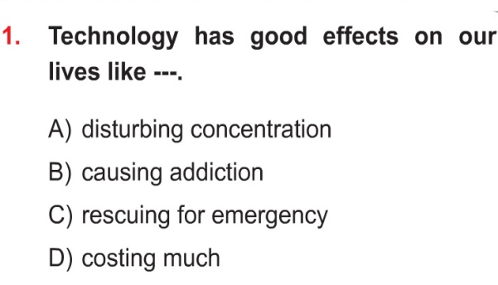 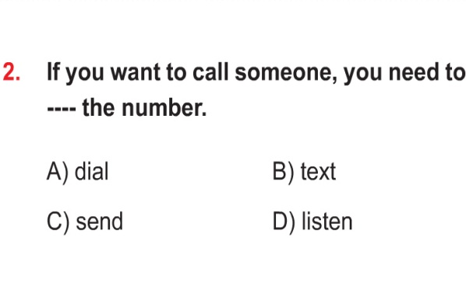

**3.**

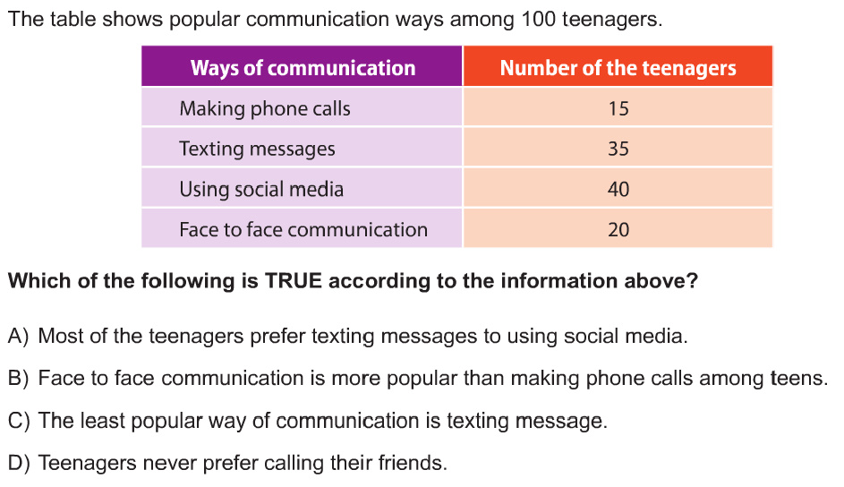

**4.**

**.**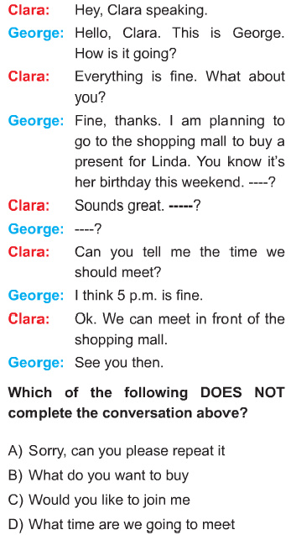

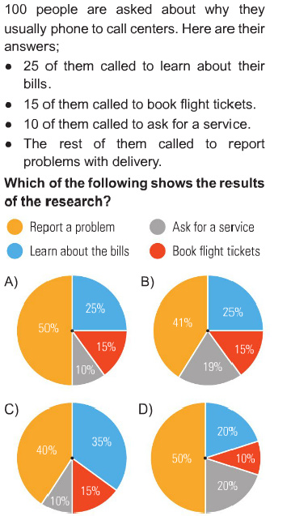



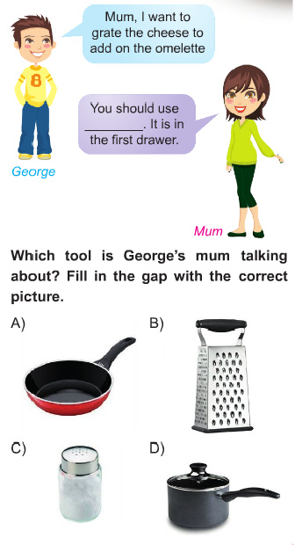

**7.**

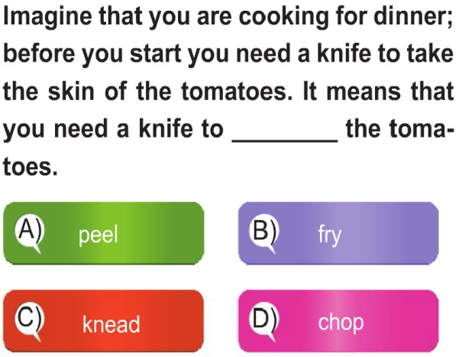

**8.**

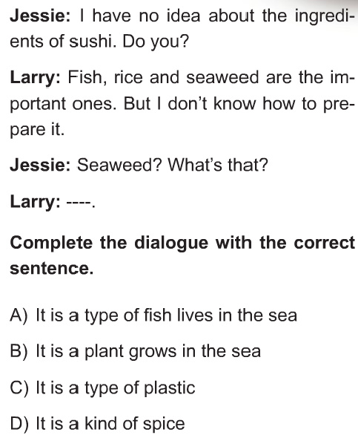 **9.**

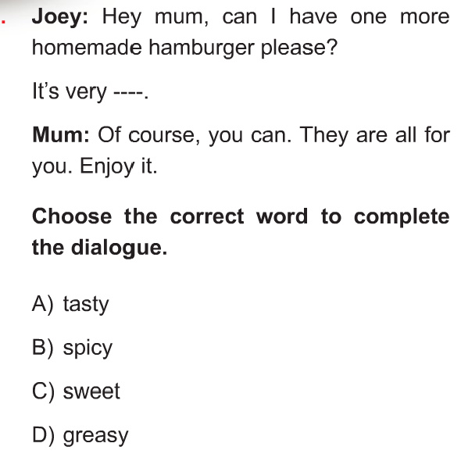

**10.**

