Name-Surname:
__________________
Class: __-__ Number: ____

- Fill in the blanks using comparatives meaningfully (5x3) 15
- Films are ____________________________ (interesting) than books.
- Friends are ___________________________
(important) than your parents.
- Russian is _________________________ (easy) than Turkish.
- Cultural holiday is _______________________ (good) than camping holiday.
- Şahan Gökbakar is _____________________ (fat) Acun Ilıcalı.

- Write the correct adjective under the given titles.(15x1)15

smart fat blue
blonde green curly
straight serious dark brown
ginger selfish hazel
slim overweight wavy

Eyes:
1_______
2_______
3_______
Hair Type:
1_______
2_______
3_______
Personality
1________
2________
3________

Body type:
1__________
2__________
3__________
Hair Color:
1__________
2__________
3__________

- Answer the questions below.(3+4+3) 10
- What is your father like ? (3P)
__________________________________________

- What does your English teacher look like? (4P)
_________________________________________________________________________________________________________________________________

- What does your father like? (3P)
__________________________________________
__________________________________________
2018-2019 EĞİTİM ÖĞRETİM YILI
ÖZEL .................. LİSESİ
7AB SINIFLARI 1.DÖNEM 1. İNGİLİZCE YAZILI SINAVI

- Complete the sentences with correct personality adjectives (5x2) 10
funny cowardly brave impatient hardworking dishonest
patient boring honest lazy

1. His dad is ................................ . He can wait for hours.
2. James is ................................ . He works long hours.
3. The clown is very ................................ . He plays a lot of tricks.
4. John Smith is a ................................ captain. He isn’t afraid to fight.
5. My sister is ................................ . She always tells the truth.
- Look at the pictures and write 5 setences for each person. (Use: “am,is,are”, “have/has”) (10x2) 20

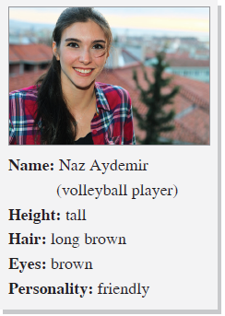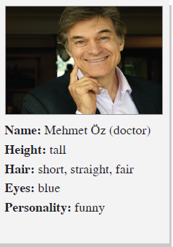

1.___________________________________________________________________________________________________________________________________________________________________________________________________________________________2.__________________________________________________________________________________________________________________________________________________________________________________________________________________________

- Look at the pictures and write general sentences. (5x3) 15
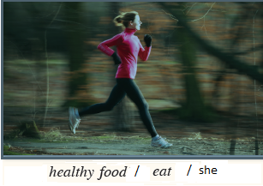
- ____________________________________
______________________________________
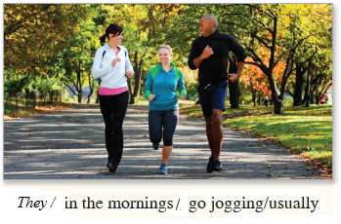
- ____________________________________
______________________________________
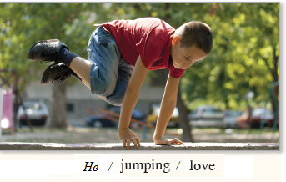
- _________________________________________________________________________
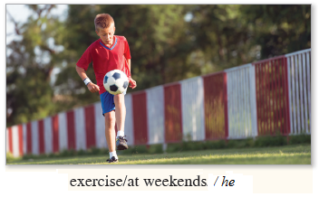
- ________________________________________________________________________
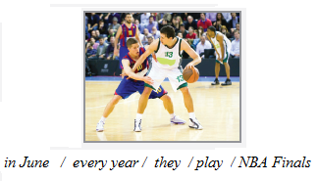
- _________________________________________________________________________

- Answer the questions.
- What time do you get up?
_____________________________________
- How often do you read books?
_____________________________________
- Who do you sit with at school?
_____________________________________
- What do you eat at breakfast?
_____________________________________
- Where do you do physical education?
_____________________________________

Good Luck!

