**2018-2019 EĞİTİM ÖĞRETİM YILI**

**………………………………………. ORTAOKULU**

**7. SINIFLAR 2.DÖNEM 1. İNGİLİZCE YAZILI SINAVI**

**Name-Surname:**

**____________________**

**Class: __-__ Number: ____**

**Date: __/__/ 2019**

**Mark: _______**

1. **Choose 15 words and write the Turkısh meanings.(15x2:30 pts)**

**Become extinct:**___________

**Claw :** _________________

**Cage :** _________________

**To find :** _______________

**forest :**________________

**hunter :**________________

**insect :**________________

**mammal :** _______________

**herbivore :** ______________

**reptile:**__________________

**prevent:** _________________

**miss** : ___________________

**recycle :**_________________

**sharp :** ________________

**create :** _______________

**meat :**________________

**move :**________________

**share:**________________

**stay** :________________

**souvenir** :_____________

**graduate:_____________**

1. **Fill in the blanks with the words given. There is one extra (!) (5x2) 10**

|  |  |  |
| --- | --- | --- |
| **informative** | **creative** | **language** |
| **violence** | **homemade** | **skip** |

1. Children are more _______________ than adults. They see things differently.
2. I don’t like horror films because there is too much ________________ .
3. Michael spends a lot of time on the net, so he often _______________ meals.
4. I prefer eating _______________ food because it is ______________ and healtier.
5. History boks are very _______________ . You can learn everythinf about the past.
6. **Match the correct picture to the type of the TV program.(10x2) 20**

**(Cartoon-News – Sitcom - Quiz show – Documentary - Horror film**

**- Sports program - Talk Show - Reality show - Cookery program)**

|  |  |  |  |  |
| --- | --- | --- | --- | --- |
| **Capture1.PNG** | **Capture2.PNG** | **Capture3.PNG** |  |  |
|  |  |  |  |  |
|  |  |  |  |  |
|  |  |  |  |  |

1. **Make advice sentences using the info given here. (5x3) 15**

**(stop overfishing) – (feed them) – (save them) - (not put there) - (not cut them down)**

1. Some dogs are hungry: _______________________________________________
2. Monkeys live in trees: _____________________________________ __________
3. Some food species can die out soon: ____________________________________
4. Pandas are at risk of extinction: ________________________________________
5. Lions are very unhappy in cages: _______________________________________

1. **Ask questions and answer . (5x2) 10**
2. **______________ is your birthday party?**

**My birthday party is_________________________________________________**

1. **______________ did you come to this school?**

**Because ___________________________________________________________**

1. **______________ is your best friend?**

**My best friend _____________________________________________________**

1. **______________ lesson do you like most?**

**I ________________________________________________________________**

1. **______________ do you get up in the morning ?**

**I ________________________________________________________________**

1. **Make simple past sentences. (5x3) 15**

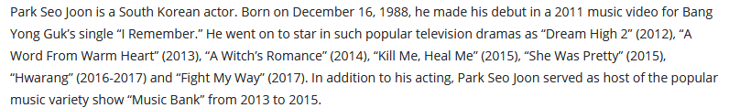

1. Where was he born? ________________________________________________
2. When did he do his first music video? ________________________ __________
3. When did he act in “Kill me, Heal me” ? _________________________________
4. Where did he become a star? _________________________________________
5. Which music show did he make?_______________________________________