2018-2019 ACADEMIC YEAR ……………………………….. SECONDARY SCHOOL

2nd TERM 2nd  WRITTEN ENGLISH EXAM FOR 7TH GRADES

***NAME/SURNAME: CLASS: NUMBER:***

**A) Match the pictures with the words. (Resimleri kelimelerle eşleştirin.) (10x2=20)**

Unplug / Increase / Paper bag / Plant / Aerosol / Planet / Rubbish bin / Pollution / recycle / pesticide

 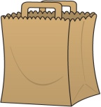  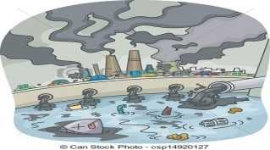 

____________ _______________ ________________ ____________________ ___________

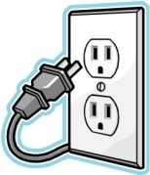 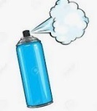 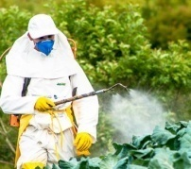  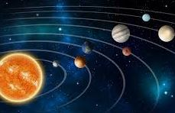

_____________ ______________ ________________ ________________ ______________

**B) Match the sentences and number the pictures. (Cümleleri eşleştirin ve resimleri numarandırın.) (5x4=20)**

1) Lisa went to the library a) to buy some bread

2) Jenny went to the bakery b) to get some medicine

3)Peter went to the hospital c) to have a cup of coffee

4)Mary went to the cafe d) to borrow some books

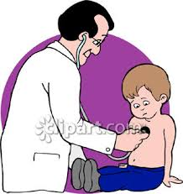5)Sally went to the pharmacy e) to see a doctor

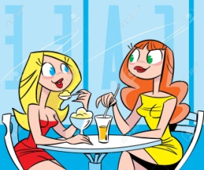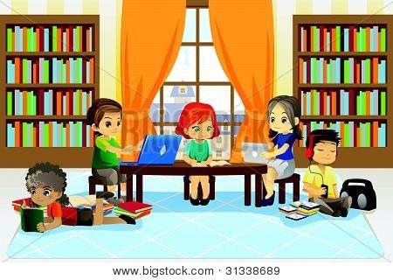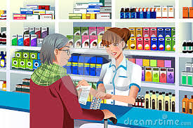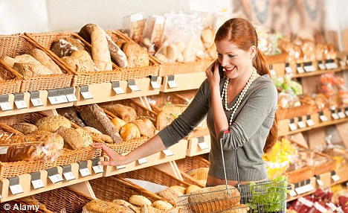

**C) Fill in the blanks with ‘’Must’’ ,‘’Mustn’t’’, “have to” , “don’t have to”, “ Should”, (use each only once) (5x4=20)**

**1. A:** These suitcases are very heavy.

**B:** I think you ………………………………... (ask) for help from somebody.

**2.** Look at that sign! You ………………………………….. (swim) here. It is dangerous.

**3.** We ……………………………….…….. (use) solar energy, because it is cheaper and environmentally friendly.

**4.** Mary’s leg is broken. Doctors say that she ………………………….……… (stay) in bed for a month.

**5.** Tom can wear T-shirts and blue jeans. At work. He …………………………………………….. (wear) to a special uniform.

**D) Fill in the blanks with “SOME, ANY, A LOT OF”. (5x2=10)**

1. Serve the ice cream with ……………………….... strawbery

jam.

1. There aren’t ……………..…………… witch costumes in this shop.
2. We are at David’s birthday party. It is really crowded here. There are …………………………… guests.
3. Would you like ………………………….. chocolate on your ice cream?
4. Is there …………………………… restaurant close to here? I am very hungry.

**E) Fill in the blanks with “much, many, a few, a little” (5x2) 10**

1. **How ………….. ……. bread do we have at home?**
2. **How ………………… should we decorate at your room?**
3. **Is there …………………. cofee in your cup?**
4. **Does James have …………………… party hats ?**
5. **Do you have ……………………… eggs in your fridge?**

**G) Fill in the blanks with “Ving”or “to V1” or “V1”.**

**(5x2) 10**

|  |  |  |
| --- | --- | --- |
| **1.** | **A: Let’s _______________ (watch) a movie today.** | **B: It is a good idea.** |
| **2.** | **A: Why don’t we ________ (swim) in the pool?** | **B: Sorry, it is not a good idea.** |
| **3.** | **A: I would like ___________ (buy) some balloons.** | **B: Sure. Here you are.** |
| **4.** | **A: I prefer ______________ (eat) icecream to ________ coke.** | **B: Me, too.** |
| **5.** | **A: I bought a bicycle ______ ____________ (go) to school.** | **B: That’s good.** |

**H. Use “Simple Future” and “Past simple”**

1. **A: I am sure Our team ______________ (win) the match.**

**B: I am afraid they _____________ (win) , because they aren’t ready.**

1. **Thomas ______________(stay) at home yesterday.**
2. **I ___________________ (probably/make) a journey next month.**
3. **The wather ____________ (be) cold yestersay, not warm.**
4. **I _____________ (begin) to act in movies in 2015.**

**Good Luck!**