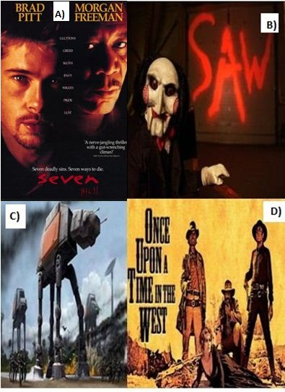

**Name-Surname:**

**____________________**

**Class: __-__ Number: ____**

**2018-2019 EĞİTİM ÖĞRETİM YILI**

**………………… ORTAOKULU**

**8. SINIFLAR 1.DÖNEM 1. İNGİLİZCE YAZILI SINAVI(B)**

**Date: __/__/ 2018**

**Mark: _______**

**Signiture:___________**

**A. Choose the best choice. (20x3) 60**

**1) Let’s _____ after the class?**

**A)** see a movie **B)** to see a movie

**C)** seeing a movie **D)** saw a movie

**2) I prefer ……… potatoes to ……… green peppers.**

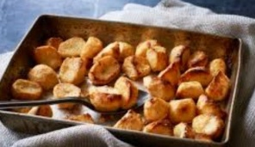**A)** roasting - fry

**B)** roasting - frying

**C)** roast - frying

**D)** roast - fry

**3)** **A: ………………………………**

**B: I like going to the cinema and hang out with friends.**

**A)** When do you spend time with your friends?

**B)** Do you like watching movies?

**C)** What do you like doing in your spare time?

**D)** Do you hang out with your friends?

**4)** A: What is James like?

B: He always tells the truth. He is …. person.

**A)** reliable **B)** hardworking  
 **C)** hanssome **D)** attractive

**5) You want to agree your friends invitation.**

**What would you say to him/her?**

**A)** Yes, that would be great, but I am tired.

**B)** Well, I don’t feel like walking.

**C)** Sure, that sounds fun.

**D)** I’m sorry but I can’t

**6) Hakan: What about .... at the cafe?**

**Eray: No , It is very noisy. I prefer ..... a quiter place .**

**A)** study - study **B)** study - studying

**C)** studying – study **D)** studying - studying

**7)** **Ahmet: The weather is very hot.**

**Ayşe : ……….. eating a cone of ice-cream?**

**Ahmet: Oh, thank you.**

**A)** Why don’t we **B)** Let’s

**C)** Shall we **D)** How about

D)

**8) Which movie type given in the dialogue is not shown in the pictures?**

**Behlül: What kind of movie do you like?**

**Bihter : I like, horror, western and sci-fi.**

**9) Aslı : Why didn’t you come to the party?**

**Kerem : Because …..**

**Aslı: That’s not a good excuse.**

**Which one comes to the blank.**

1. I had an important exam
2. I was washing the car.
3. I was at the hospital with my sister
4. We had an accident.

**10) He prefers………....golf to…………football.**

[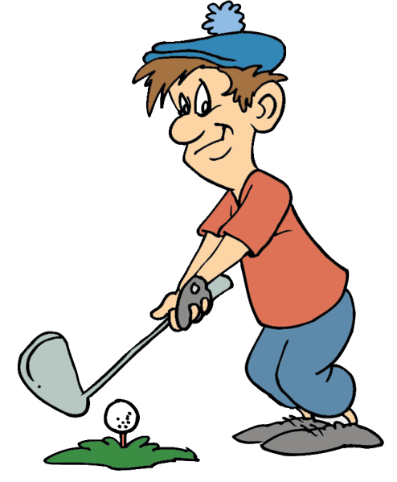](http://www.cliparthut.com/geese-playing-golf-clipart.html)

**A)** playing—playing

**B)** to play----to play

**C)** play---play

**D)** played----played

**11) Tarık: What are you doing tonight? Would you like to go out?**

**Samet: ………………… I’m going to study Maths tonight.**

**A)** That would be great **B)** That sounds nice.

**C)** I’d love to but  **D)** Great idea.

**12) A: ……………. ?**

**B: It’s Miley Cyrus’ .**

**A)** Where is Miley Cyrus?

**B)** Who is Miley Cyrus?

**C)** Whose song is it?

**D)** What car is it?

**13) He always tells the truth. He is a ……... boy.**

**A)** ridiculous

**B)** trustworthy

**C)** serious

**D)** outgoing

**14**) **A: ………………………………**

**B: I love movies very much. Let’s do it.**

**A)** How about watching “Hunger Games 2” after school?

**B)** Let’s play computer games.

**C)** Why don’t we go to concert tomorrow?

**D)** Shall we do our homework together?

**15) I really like winter sports. I ….. try snowboardig.**

**A)** hate

**B)** never

**C)** dislike

**D)** would like to

**16) What is the synonym of underlined word?**

**Serhat: I didnt’t like the drummer in the pop concert.**

**Aysel: Me too.**

**A)** performer

**B)** batterist

**C)** band

**D)** guitarist

**17) Thanks for invitation but I can’t join your party**

**because I ……….**

**A)** am going to visit my brother

**B)** is going to play computer games

**C)** am not like cakes

**D)** are going to go to the school

**B) Do 18 and 19 looking at the table**

|  |  |  |  |  |
| --- | --- | --- | --- | --- |
|  | **Jazz** | **Classical** | **Rock** | **Country** |
| **Susan** | **√** | **√** | **√** | **√** |
| **Mike** | **x** | **x** | **√** | **x** |
| **Peter** | **√** | **x** | **√** | **√** |

**18) Everybody**

**A)** likes Rock music

**B)** hates jazz music

**C)** dislikes country music

**D)** likes classical music

**19) Susan**

**A)** is fond of Roc music

**B)** is keen on all kinds of music

**C)** doesn’t like to country music

**D)** never listens to classical music

**20) Write the words below in the blanks orderly.**

**In the morning, ….. I wash my face. ….. I have my breakfast. ….. I meet my friends at the bus stop. ….. I arrive at school right on time.**

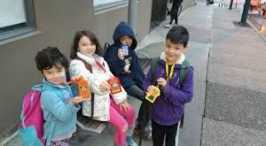

**A)** Then

**B)** First

**C)** Finally

**D)** After that

**B) Write the words for the given pictures. (15x2=30)**

to insult impressive to have diner to get high grades folk music

to depend on to enjoy cheers To recommend to slice

to dice to chop relationship attractive To pay attenion

|  |  |  |  |  |
| --- | --- | --- | --- | --- |
| **chop onions.JPG** | **slice.JPG** | **get high grades.jpg** | **dice.jpg** | **enjoy.JPG** |
|  |  |  |  |  |
|  | **relationship.JPG** | **have dinner.JPG** | **Ekran Alıntısı.JPG** | **cheers.PNG** |
|  |  |  |  |  |
| **impressive.JPG** | **depend on.JPG** | **attractive.PNG** | **pay attention.JPG** | **apologize.JPG** |
|  |  |  |  |  |

**C) Circle the correct choice. (5x2) 10**

|  |
| --- |
| **1.**Would you like to **(go / going)** to the cinema with me? **2.**What about **(watch / watching)** a cartoon on TV?  **3.**Let’s **(drink / drinking)** something cold? **4.**How about **(play / playing)** table tennis?  **5.**Shall we **(dance / dancing)** together? |

**☺☺HAVE A GOOD LUCK ☺☺**