**Date: __/__/ 2018**

**Mark: _______**

**Name-Surname:**

**____________________**

**Class: __-__ Number: ____**

**2018-2019 EĞİTİM ÖĞRETİM YILI**

**…………………………………………… ORTAOKULU**

**8. SINIFLAR 1.DÖNEM 2. İNGİLİZCE YAZILI SINAVI (A)**

**A. Choose the best choice.(20x3) 60**

**1.**

**2. 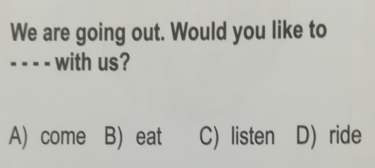  
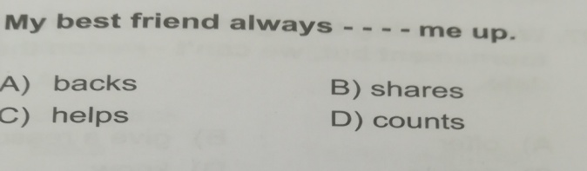**

**3.**

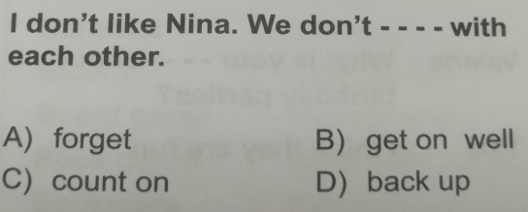

**4.**

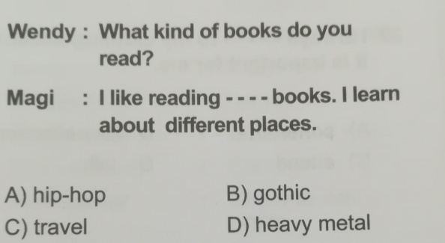

**5**

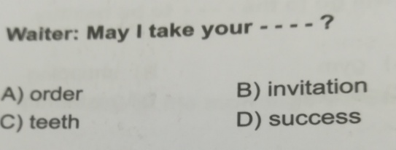

**6.**

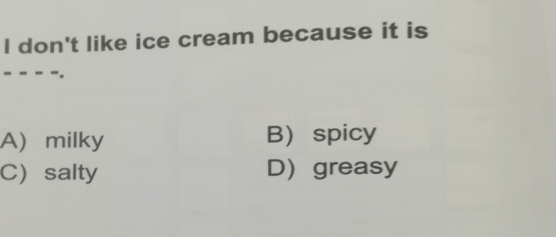

**7**

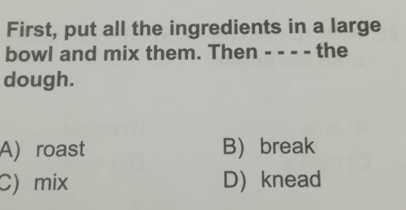

**8.**

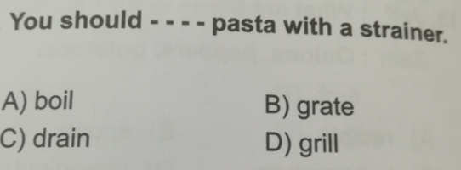

**9.**

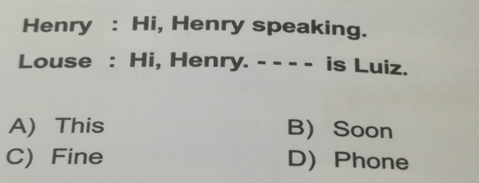

**10.**

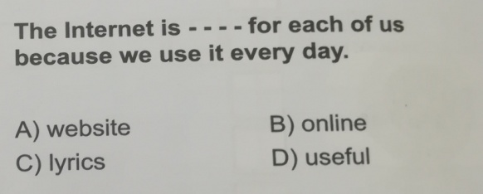

**11.**

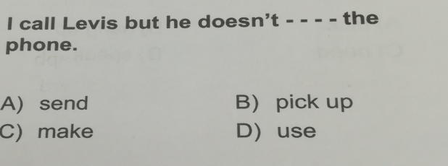

**12.**

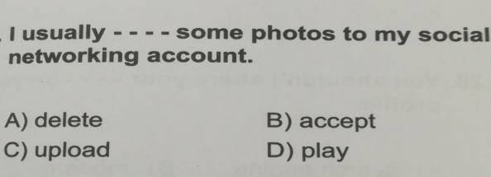

**13.**

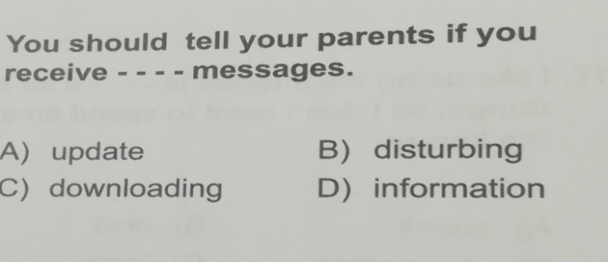

**14.**

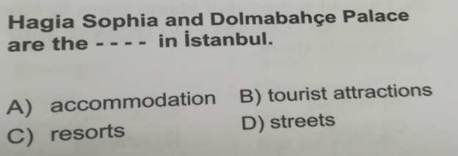

**15.**

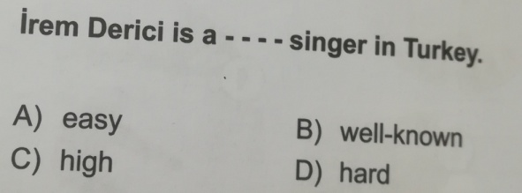

**16.**

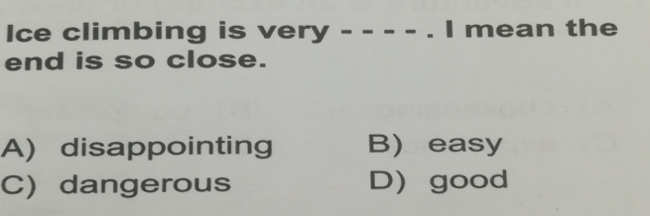

**17.**

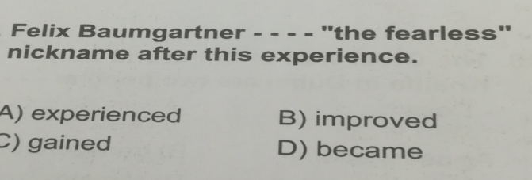

**18.**

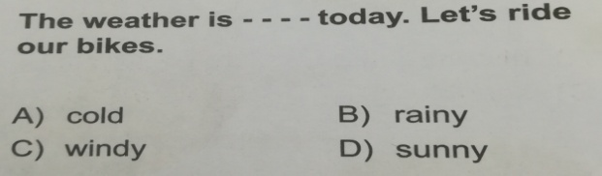

**19.**

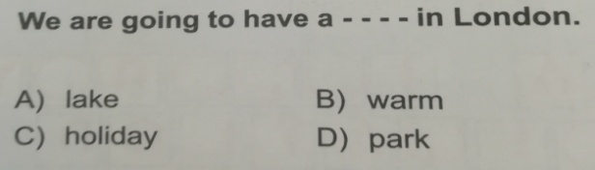

**20.**

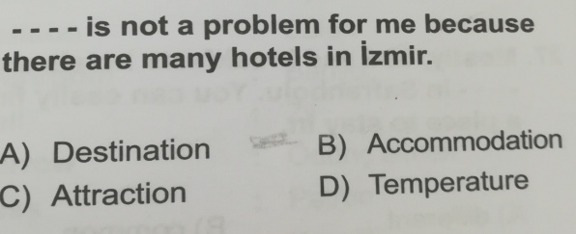

**21.**

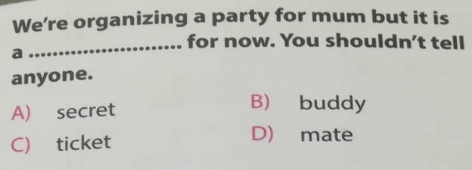

**22.**

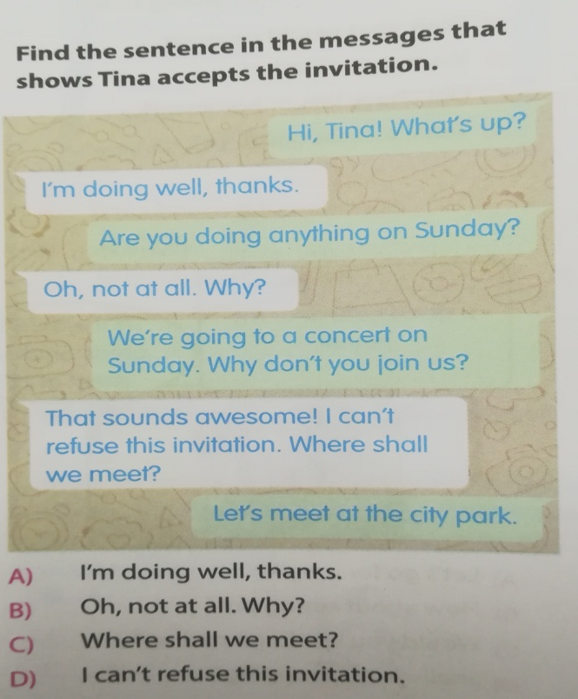

**23.**

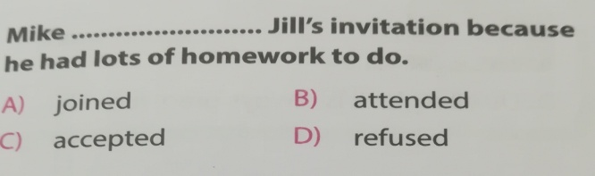

**24.**

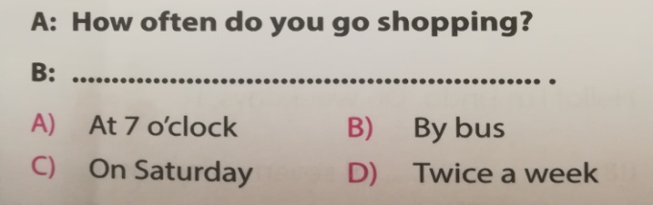

**25.**

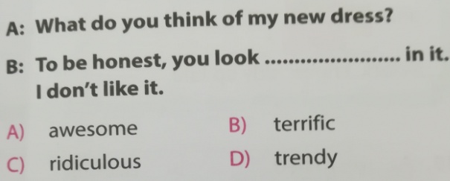

**26.**

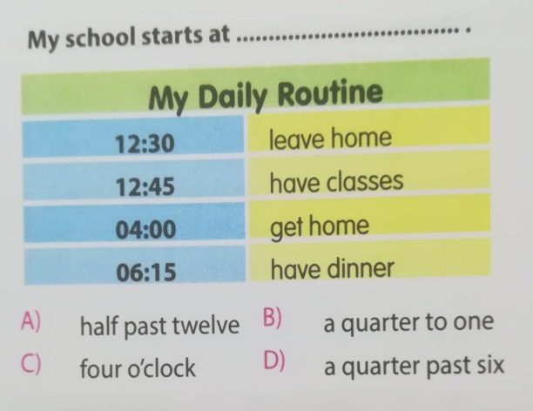

**27.**

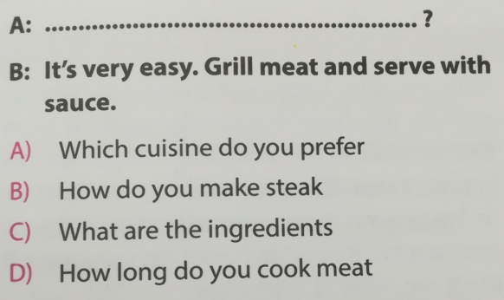

**28.**

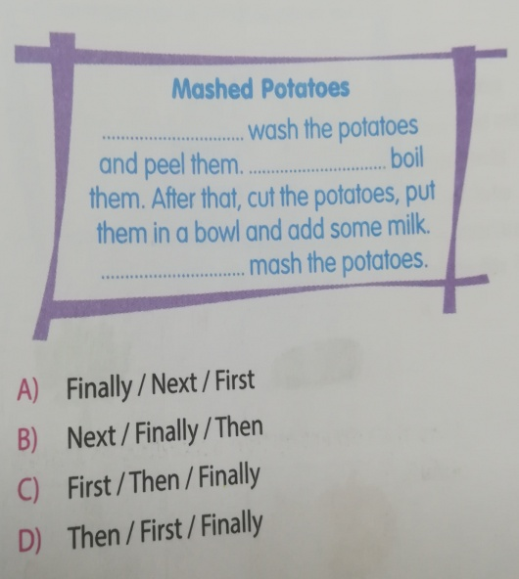

**29.**

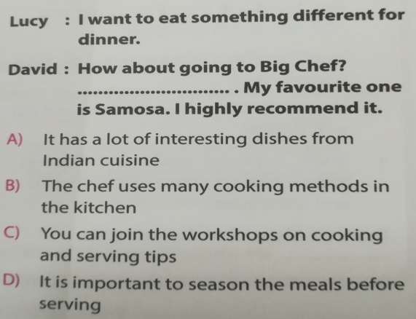

**30.**

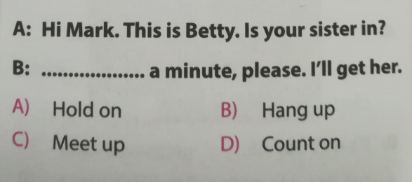

**31.**

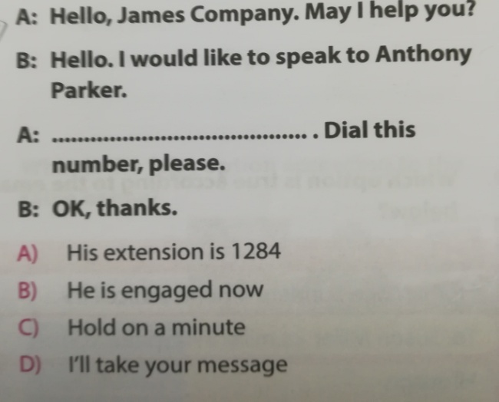

**32.**

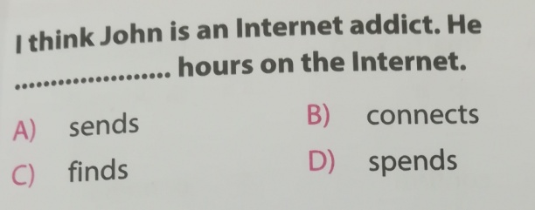

**33.**

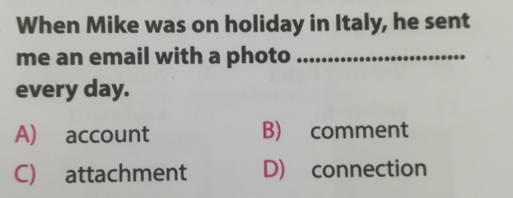

**34.**

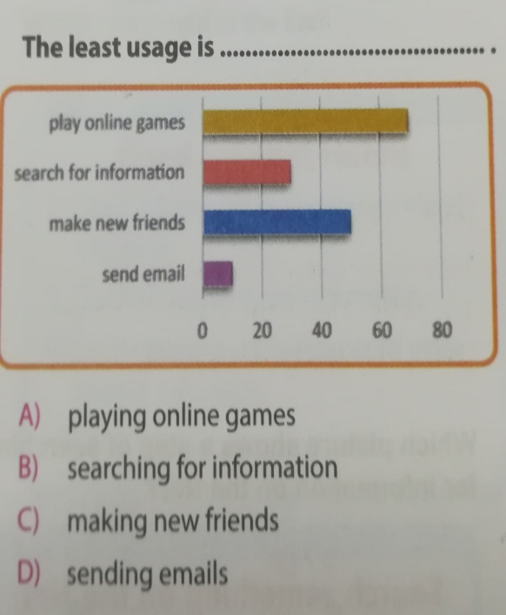

**35.**

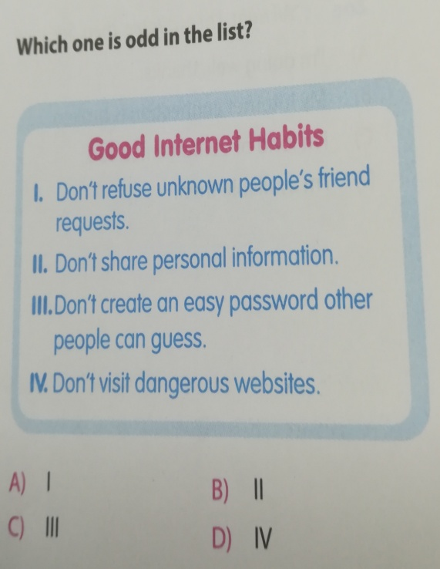

|  |  |  |  |  |  |
| --- | --- | --- | --- | --- | --- |
| **1 ( )** | **DISH** | **A** | **MUTFAK** | **B** | **YEMEK** |
| **2 ( )** | **BAD LINE** | **A** | **KÖTÜ SÖZ** | **B** | **BOZUK HAT** |
| **3 ( )** | **B&B** | **A** | **YATAK VE KAHVALTI** | **B** | **YATAK VE BANYO** |
| **4 ( )** | **GRILL** | **A** | **FIRINA VERMEK** | **B** | **KIZARTMAK** |

**36.**

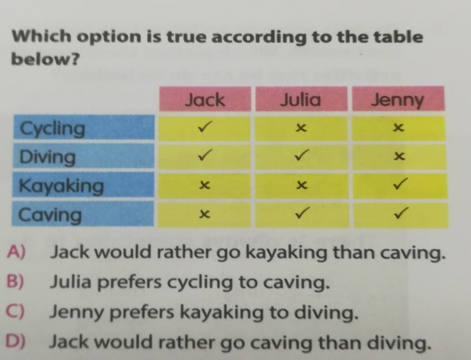

**37.**

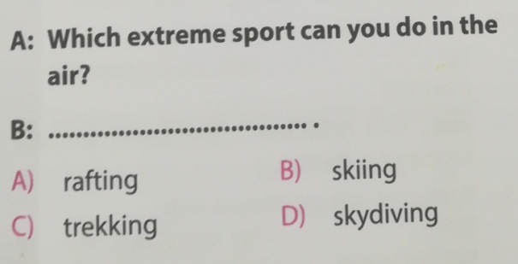

**B. Choose the correct meaning for the word given. (15x2) 30**

|  |  |  |  |  |  |
| --- | --- | --- | --- | --- | --- |
| **1** | **DECIDE** | **A** | **Karar vermek** | **B** | **Reddetmek** |
| **2** | **EXIBITION** | **A** | **Sergi** | **B** | **Gezi** |
| **3** | **BEHAVE FAIRLY** | **A** | **Yaramazlık yapmak** | **B** | **Adil davranmak** |
| **4** | **FASCINATING** | **A** | **Ürkütücü** | **B** | **Büyüleyici** |
| **5** | **A CLOVE OF** | **A** | **Bir diş** | **B** | **Bir tutam** |
| **6** | **BOWL** | **A** | **Kase** | **B** | **Davul** |
| **7** | **DISTURB** | **A** | **Vaz geşmek** | **B** | **Rahatsız etmek** |
| **8** | **CONVERSATION** | **A** | **İletişim** | **B** | **Konuşma** |
| **9** | **GENDER** | **A** | **Gönderen** | **B** | **Cinsiyet** |
| **10** | **IGNORE** | **A** | **Dışlamak** | **B** | **Horlamak** |
| **11** | **AMBITIOUS** | **A** | **Uydurma** | **B** | **Hırslı** |
| **12** | **COURAGE** | **A** | **Cesaret** | **B** | **Depo** |
| **13** | **CHARMING** | **A** | **Üzücü** | **B** | **Büyüleyici** |
| **14** | **BUDGET** | **A** | **Bütçeye uygun** | **B** | **Paket** |
| **15** | **CLIMATE** | **A** | **İklim** | **B** | **Otomatik** |

**JOKER WORDS ARE BELOW. DONT FORGET TO WRITE THE CHANGED QUESTION NUMBER**