Name-Surname:
__________________
Class: __-__ Number: ____

- Fill in the blanks “countries” and “nationalities” (10x1) 10
Nationalities

_______________
Greek
_______________
Chinese
_______________
German
_______________
Australian
_______________
Italian

Countries

France
_____________
Tu r ke y
_____________
Britain
_____________
Spain
_____________
Portugal
_____________

- Write instructions fort he target (5x3)15
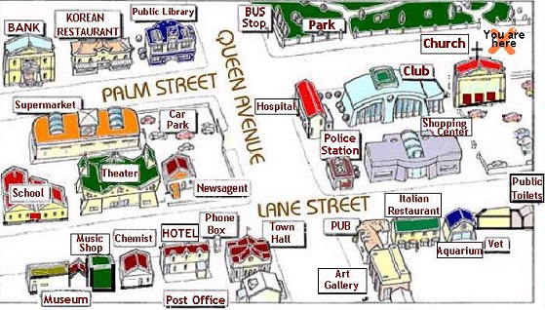
- How can I go to Korean restaurant?
_________________________________
_________________________________
- How can I go to club?
_________________________________
_________________________________
- How can I go to Park?
_________________________________
_________________________________
- How can I go to Shopping center?
_________________________________
_________________________________
- How can I go to the school?
_________________________________
_________________________________

2018-2019 EĞİTİM ÖĞRETİM YILI
........................................ LİSESİ
9A SINIFI 1.DÖNEM 1. İNGİLİZCE YAZILI SINAVI

- Write sentences about the person in the table below.(5x2) 10

1.Name-Surname: Fabio Peraldo 2.Age: 35
3.Country: England 4.Nationality: English 5. Occupation: architect

- ___________________________________
- ___________________________________
3._____________________________________
4._____________________________________
5. _____________________________________

- Answer the questions according to the text . (10x2) 20

1.I’m Jacob and I’m a Canadian actor. I’m here in San Francisco to study dancing at a world-famous school. It is in a gorgeous building in the city centre. The instructors are very talented people. They are really good dancers.

2.Hi, I’m Sue from the UK. I’m a chemist. Now
I’m in Paris with one of my colleagues and six students for a youth project. My colleague’s name is Brian. There are three girls and three boys in our group. Our project partner is a science school.

- What is Jacob’s job?

______________________________________
- What does Jacob study?
______________________________________
- What is the school building like?
______________________________________
- What are the instructors like?
______________________________________
- Where is Sue now?
______________________________________
- How many students are there in the group from UK? ________________________________
- What kind of school is their partner school?
______________________________________
Find a word having the same meaning from the text.
- Beautiful: _______________________
- Friends: ________________________
- Smart:__________________________

- Find the pairs in the word box and complete the chart. (5x2) 10
brother daughter father son
husband mother sister aunt
wife uncle

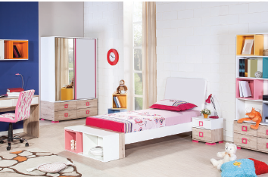

 | 
_______________  _______________  _______________  _______________  _______________ | _______________  _______________  _______________  _______________  _______________

- Look at the pictures and write the names of 5 items. (10x1) 10
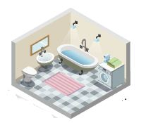
1.______________ 2. ______________
3.______________ 4. ______________
5.______________

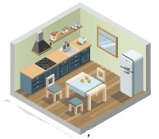
1.______________ 2. ______________
3.______________ 4. ______________
5.______________

- Look at thepicture and answer the questions.
(5x2) 10
On In Between Under Near

- Where is the pillow?
______________________________________
- Where is the bedside table?
______________________________________
- Where are the books?
______________________________________
- Where is the study table?
______________________________________
- Where is the wardrobe?
______________________________________

- Write a short letter of 5 -10 sentences (5x3)15
____________
___________________________________________________________________________________________________________________________________________________________________________________________________________________________________________________________________________________________________________________________________________________________________
________

