**Date: __/__/ 2019**

**Mark: _______**

**Name-Surname:**

**____________________**

**Class: __-__ Number: ____**

**20178-2019 EĞİTİM ÖĞRETİM YILI**

**………………………………. ORTAOKULU**

**9-A SINIFI 1.DÖNEM 2. İNGİLİZCE YAZILI SINAVI**

1. **Look at the pictures and write possessive (have/has got) sentences (5x3)15**

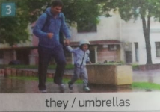

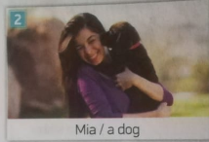

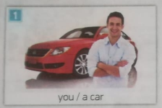

3._______________________

2.______________________

1.______________________

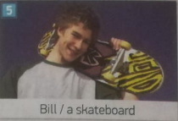

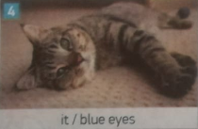

4._______________________

5._______________________

1. **Fill in the blanks with question words. Use “How often, What,Where, How, Who” only once. (5x3)15**

**3.A:** _____ time is it ?

**B:** It is 5 o’clock.

**2.A:** ___ old is your friend ?

**B:** She is 13 years old.

**1.A:** _____ are my books ?

**B:** They are on your desk.

**5. A:** _____ do you help you mum ?

**B:** I help her once a week.

**4.A:** _____ eats fish ?

**B:** Mehmet eats fish.

1. **Where is the ball? (5x2)10**

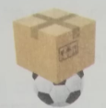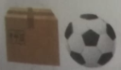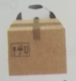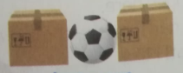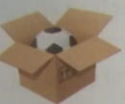

1. **(2) (3) (4) (5)**
2. **_______________________________________**
3. **_______________________________________**
4. **_______________________________________**
5. **_______________________________________**
6. **_______________________________________**
7. 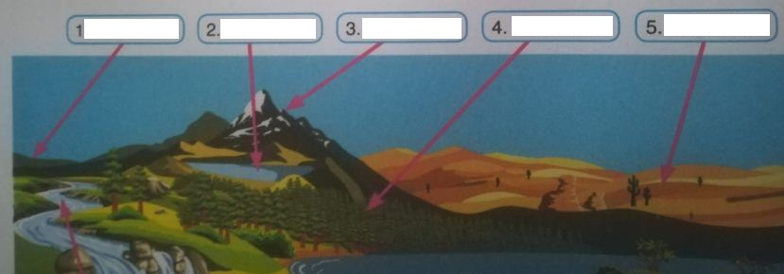**Write the names of the geographical features (5x2) 10**
8. **Make comperatives and superlatives. (5x2) 10**
9. I think baby boys are _____________________________ (pretty) baby girls.
10. Tigers are _________________________ (fast) monkeys.
11. Laptops are ___________________________ (expensive) tablets.
12. My school bag is ____________________________ (big) of all the bags in my class.
13. Ahmet drives __________________________(good) than me.
14. **Read the text and answer the questions. (5x2)10**

Schools in African villages are different from schools in Europe. There aren’t any libraries, computer labs or sports halls. Sometimes, there aren’t any classrooms and students have lessons outside. They haven’t got any posters or maps, but they have got some books and their teacher has got blackboard. There are a lot of students., but there is only one teacher. Students haven’t got any school uniforms, but they are happy, because there is a school in the village.

1. What are the missing actvities in Africa? ____________________________________________________________
2. Where do the students have their lessons? ___________________________________________________________
3. Can you see the other countries in the maps in African schools? Why? ___________________________________

_______________________________________________________________________________________________

1. Do they wear school uniforms at school? ____________________________________________________________
2. Why are the African students happy? ______________________________________________________________
3. **Write the correct word of “is/are”, “Some”, “Any” or “A/An” (5x2) 10**
4. We have got _________ ice-cream in the fridge.
5. There aren’t _________ eggs fort he omelette.
6. There _______ pencils on the table.
7. There is _________ bread on the table.
8. _____ there some apple juice in the carton?
9. **Put the words into the correct order to make Present Simple sentences. (5x2) 10**
10. twice a year / travel / to London / my family members.

__________________________________________________________________________

1. does / every week / not / Tom / new clothes / buy.

__________________________________________________________________________

1. environment / always / we / destroy.

__________________________________________________________________________

1. do / earn / Terry and Jane / their living / how?

__________________________________________________________________________

1. watch / Terry / every Saturday / this show / does

__________________________________________________________________________

1. **Read the definitions and fill in the blanks using nature words. (5x2) 10**
2. ______________________ is an extremely large wave after an earthquake.
3. ______________________ is a sudden explosion of volcanic material.
4. ______________________ is a long period when there is a little rain or no rain.
5. ______________________ is a large amount of water beyond its normal limits.
6. ______________________ is a storm that moves over the sea or ocean.