**2018-2019 EĞİTİM ÖĞRETİM YILI**

**…………………………………… LİSESİ**

**9-A SINIFI 2.DÖNEM 1. İNGİLİZCE YAZILI SINAVI**

**Name-Surname:**

**____________________**

**Class: __-__ Number: ____**

**Date: __/__/ 2019**

**Mark: _______**

1. **Fill in the blanks using the words below. There are 2 extra words. (5x3:15 marks)**



1. In Japan, people have very strong buildings because they often have __________.

2. When there is __________, the land dries and crops die.

3. The __________ damages the roof of the buildings in the West Atlantic Ocean very often.

4. After the __________, the water goes down and the land usually dries in weeks.

5. A small snowball can start a(n) __________ on the mountains in Peru.

6. When a(n) __________ comes; high waves hit the coast and kill people in Indonesia.

1. **Match the words to make collocations. (5X2) 10**

|  |  |  |
| --- | --- | --- |
|  | spiky _______________ | skin  hair  eyes  man  hair |
|  | good-looking _______________ |
|  | green _______________ |
|  | dark _______________ |
|  | dyed _______________ |

1. **Fill in the blanks using “*am not, isn’t, aren’t, don’t or doesn’t*.” (5x2) 10**

1. They __________ walk to school every morning. They sometimes ride their bikes.

2. Mary & Sue __________ in the same school.

3. Bill __________ a good runner because he __________ practise very often.

4. Students __________ use their mobile phones in school.

5.The girl __________ happy because she __________ like her birthday presents.

1. **Put the words in the correct order and rewrite the sentences. (5x3:15 marks)**
2. makes / me / usually / a / my / for / mum / cake

_______________________________________________________________ .

1. early / up / do / get / always / you

_______________________________________________________________?

1. cheese / never / with / eats / Julia / pasta

_______________________________________________________________ .

1. story / reads / English / rarely / he / an / book

_______________________________________________________________ .

1. dance / class / every / I / a / Sunday / take

_______________________________________________________________ .

1. **Put the verbs below into the “present continuous” form to complete the sentences.(5X3)15**

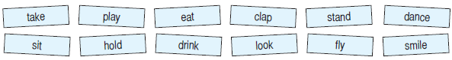

1. Sarah, my favourite popstar looks happy. She ________________ .
2. The birds ________________ high in the sky. The footballers are watching them.
3. The band ________________ my favourite song. Let’s dance.
4. John ________________ photos of the famous people in the ball.
5. My wife and my son ________________ their burgers in the cafe now.
6. 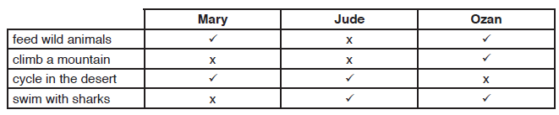**Write questions and answers with “*can*”. (5x3:15 marks)**

**1.** Mary / feed animals?

***A:*** *___________________________________ ?*

**B:** ___________________________________

2. Jude and Mary / climb mountains?

**A:** ____________________________________?

**B:** ____________________________________.

**3.** Ozan / Cycle in the desert?

***A:*** *___________________________________ ?*

**B:** ___________________________________

**4.** Jude and Ozan / swim with sharks?

***A:*** *___________________________________ ?*

**B:** ___________________________________

**5.** Ozan / cycle in the desert?

***A:*** *___________________________________ ?*

**B:** ___________________________________

1. **Choose the correct “adjective or adverb” . (5X2)10**
2. Annie cycles ***bad*** / ***badly*** on sandy roads.
3. It is an ***easy*** / ***easily*** route for a cyclist.
4. The insects move ***fast*** / ***fastly*** when it is dark in deserts.
5. The lake near the valley is very ***beautiful*** / ***beautifully***.
6. Zoo keepers look after the animals ***careful*** / ***carefully***.
7. **Put the adjectives into the comperative form. (5x2) 10**

**Ex:** I am short, but my favourite actor is ­­___***shorter than__*** (short) me.

**Ex:** Mr Smith is __**good-looking**__ (good-looking) Mr Rogers. He is always fit.

1. Kevin Costner’s eyes are __________________ (big) Richard Gere’s. They are so beautiful.
2. Jackie is ___________________ (thin) girl in the band. I love her.
3. Miley Cyrus is ___________________ (attractive) celebrity I’ve ever known.
4. Ayşe is ___________________ as (tall) me. We are medium height.
5. My favourite popstar is ______________ (young) yours, but he looks _____________ (old).

**HAVE A GOOD LUCK ☺☺**