Name-Surname:
__________________
Class: __-__ Number: ____
2018-2019 EĞİTİM ÖĞRETİM YILI
.................. LİSESİ
10-A SINIFI 1.DÖNEM 1. İNGİLİZCE YAZILI SINAVI

- Read the text and answer the questions below. (10x4) 40

Everyday Life Habits Matter: Small Changes Make a Big Difference¹
According to a recent study, bad habits such as smoking, not exercising, not eating enough fruit and vegetables can age you by more than 10 years and even steal from your life quality. Fortunately, you are not desperate.
Making just a few changes in your everyday life can help you live longer. Here are some of these changes and how applicable they are according to 100 interviewees.
Read to cope with stress: Reading does not only help you learn more and achieve better scores but also helps to cope with stress. While you are reading something in a motivated way, you will be away from the stress of everyday life, and being away from stress will be of great help for a healthier life because stress is one of the
worst enemies of human health. 82 % of the interviewees believe that this is easily applicable.
Stay out of the sun: Remember that it is never too early or too late to start to use sunscreen. Rays of the sun cause skin cancer or, at least, wrinkles and fine lines. Hats and sunglasses are also of great help.
Avoid loneliness, reach out: You are at greater risk of heart disease without a strong network of friends and family. Loneliness can be as dangerous as having high cholesterol or even smoking. Hang around with friends, share problems with them, and socialize whenever possible.
One way of achieving this at school is to join extracurricular activities. Visiting your elderly relatives as often as possible is another way. 56%
of the interviewees think that this is not easy to do due to everyday rush while it is OK for the other 44%.
Eat fruit and vegetables: You should see fruit and vegetables as nutritional powerhouses because they are full of fiber and vitamins. Take time to get at least three servings of fruit and vegetables in your everyday
Focus on fitness: Daily exercise, especially with running, can add up to four years to your life. It has positive effects on your heart, mind and metabolism. Do not waste much of your time in front of the TV or surfing the Net. Do them in moderation. Instead, move around. If you cannot run, a quick 30 minute walk will be OK. Walk to school and work if possible. 41% of the interviewees say they have already tried to focus on fitness and it is a challenging everyday life.
Consult and Cooperate: When you try to cope with all the difficulties on your own, a more stressful life or period is unavoidable. Remember that you are not a super hero and consulting and cooperating with others is a strength. At school, friends, teachers, and school counselors are all there to share. You will see that things will get better when you consult or cooperate. However, 30% of our interviewees find it applicable.
Get enough sleep: Sleep plays an important role in your physical health. It is a part of healing and repairing your heart and blood vessels. Ongoing sleep deficiency, not getting enough sleep, is linked to an increased risk of heart disease, kidney disease, high blood pressure, diabetes and stroke. Learn how much sleep you need by age and improve your sleeping habits. Go to bed and wake up at the same time every day.

- What does the 1st underlined sentence mean? (“With a small effort you can do many good things for your sake” or similar answers.)
- What are the things you can do by reading?
(You learn more, achieve beter scores and cope with /manage stres)
- What dangers can you have from sun?
(skin cancer or, at least, wrinkles and fine lines.
- What causes heart disease more than high collestrol?
(Loneliness)
- What perevents people from visiting elderlies?
Explain. (everyday rush: Traffic jam and busy life of the cities)
- What are the nuritional powerhouses? Why should you eat fruit and vegetables? What is the suggested use ?(Fruits and vegetables. because they are full of fiber and vitamins.At least three servings everyday)
- What can replace a regular exercise? What percent of people apply it to their lives? (Running and Walking. %41)
C)
(10x2)20
- What do the %30 of interviewees think about consulting? (consulting and cooperating friends, teachers, and school counselors )
- What are the good and bad results of a good sleep? (Adv: healing and repairing your heart and blood vessels.
is living
Disadv: an increased risk of heart disease, kidney disease, high blood pressure, diabetes and stroke.
don’t like
don’t understand
gets up
- Which change is the most important for you? Why? (Personal answers)
are leaving

B.Fill in the blanks using the words given.(10x2)20
does start
are going
elective aware of compulsory
adapted warm-up
freshman submit challanging
suffer from extracurricular
doesn’t believe
are
doing
- When will you … submit.. your assignment?
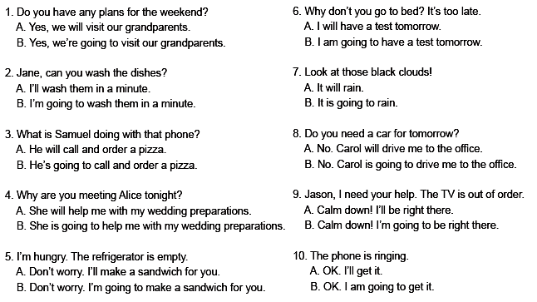
- In our school, Maths is a compulsory lesson, but French is elective .
- After school ,we have social clubs and courses. We call them extracurricular activities.
- Can you expect an optimum
performance from a footballer if he doesn’t do any warm-up?
- If you don’t study regularly, you suffer from failure.
- Most students are worried and nervous about their first days at a new school as a freshman .
- A class teacher must be aware of the needs o his/her students.
- Is Extreme-sports club a/an challanging one?
- A student should get adapted to her/his new teacher’s attitude quickly.


D) Choose the best answer.(10x2) 20

