**2018-2019 EĞİTİM ÖĞRETİM YILI**

**…………………………………………… LİSESİ**

**10-A SINIFI 2.DÖNEM 1. İNGİLİZCE YAZILI SINAVI**

**Date: __/__/ 2018**

**Mark: _______**

**Name-Surname:**

**____________________**

**Class: __-__ Number: ____**

1. **Read the following dialogue extracts related to different situations and fill in the missing parts with the appropriate expressions in the box. (10X2) 20**

|  |  |  |  |  |
| --- | --- | --- | --- | --- |
| **single** | **availability** | **check in** | **departures** | **window** |
| **flights** | **all-inclusive** | **reservation** | **vacancies** | **cost** |

1. **Customer:** I’d like to make a **__________________** .

**Receptionist:** Certainly sir. For when?

1. **Customer:** I have to be there before 10 in the morning. What ______________ do you have on the 15th?

**Booking Clerk:** Well, we have 6.30, 7.30 flights.,

1. **Customer:** And, I’d like a __________________ seat please!

**Booking Clerk:** OK., Let me check the __________________ .

1. **Customer:** OK. That suits us.

**Receptionist:** By the way, our hotel doesn’t give _____________ stays. We only have half board stays.

1. **Customer:** Do you have any late afternoon ._____________________?

**Booking Clerk:** Oh, I’m sorry. We have only morning flights.

1. **Customer:** I’ll _________________ tomorrow and check out on Wednesday.

**Receptionist:** Let me check for the __________________ ma’am!

1. **Receptionist:** What sort of room would you like?

**Customer:** I’d like a ____________________ room.

1. **Customer:** How much does it ____________________?

**Booking Clerk:** That comes to 500 $, tax included.

1. **Read the text and answer the questions. (5x3) 15**

There are many types of vacation we can list. As any other things in our lives, we consume fast and are easily fed up with usual vacation types, so new types of vacation have appeared nowadays. Here are three new vacation.types some of which you may not have heard before. You can read and plan your upcoming vacation accordingly.

**Voluntourism**

Voluntourism is a popular kind of international travel. It helps you contribute to the development of a country while exploring around at the same time. When you participate in a well-organized volunteering project, you help implement a long-term development of a country or culture. You should use your skills, time and energy to make a difference that may last longer after you have come back home. In your spare time, you can go sightseeing.

**Ecotourism**

Ecotourism is an environment- friendly travel to natural areas in order to enjoy and appreciate nature and cultural features. If you are sensitive about environment and the well-being of local people, ecotourism is just for you.

**Digital Detox**

When you feel too much connected and you are losing the pleasure of the real communication, you should immediately have a digital detox holiday. This may keep you away from the digital world for some time. Digital detox vacations offer you a way to escape from your busy routines

1 Why do the people escape from usual forms of vacation.?

____________________________________________________________________________________

2 What is voluntourism?

___________________________________________________________________________________

3 What do you do you do in a voluntourism for a country and culture?

___________________________________________________________________________________

4 What is the aim of ecotourism?

___________________________________________________________________________________

5 What should you do if you have a Digital Detox holiday?

___________________________________________________________________________________

1. **Write (T) for true sentences and (F) for false sentences. *(5x3) 15***
2. There are 4 types of new vacation. (T) - (F)
3. For voluntourism, you must go to another country. (T) - (F)
4. In voluntourism, you should use your energy to make a difference. (T) - (F)
5. Only ecologically sensitive people prefer ecotourism. (T) - (F)
6. If you are a technology addicted person you can have a Digital Detox holiday.. (T) - (F)
7. 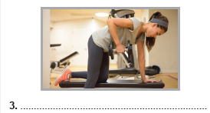Jane has changed her habits recently. Here are the things she did before. Look at the pictures and write them in sentences.(5x4) 20

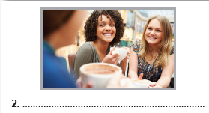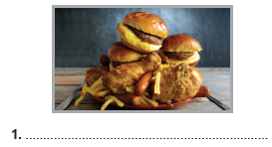

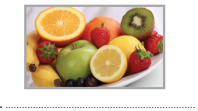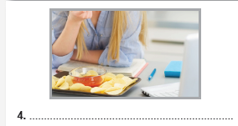

**5**

1. Make “when” and “ while” sentences in past simple.  *(5x3) 15*

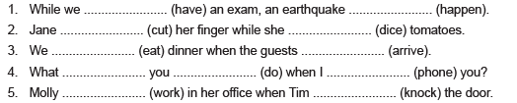

1. Make “First Type Conditional Sentence”
2. If you ________________ air conditioner, you ________________ energy and reduce your CO2 emissions.(not use /save)
3. you ________________ to use air conditioner If you _______________ cool inside, (feel – not need)
4. they ______________ your rooms from the direct sun lights If you ____________ trees in front of your windows, (plant / prevent)
5. If your air conditioners _________________ hard, they ____________________ more energy. (work / consume)
6. If you ______________ less sun lights in your room, you _____________________ cooler inside. (have / be)