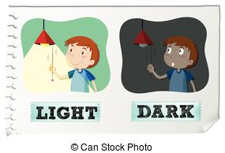 ***4 – A BURSLULUK SINAVI SORULARI***

***1. Yandaki görseli ifade eden cümle hangisidir ?***

A) Sit down

B) Be quiet

C) Clean the board

D) Turn off the lights

2. ‘***’ I / in / may /please/ come ? ‘’*** **kelimelerinin doğru sıralanışını aşşağıdakilerden hangisidir?**

A) I may please come in?

B) Please I come in may?

C) Come in may I , please ?

D) May I come in, please?

**3*. ‘’ Close ............*’’ yandaki ifadeyi tamamlayan kelime hangisidir?**

A) around

B) your book

C) the board

D) down

**I am Japanese.**

**4. Resim de verilen cevap hangi soruya aittir?**

A) Where are you from?

B) How old are you?

C) What nationality are you?

D) Where is Japan?

**5. *X. __________________?***

***Y. It is mine.***

A) Whose car is that?

B) Where are you from?

C) Are you French?

D) Where is it from?

***1. Good morning . I m Ceren . What is your name?***

***2. Nice to meet you too.***

***3. I m from USA. What nationality are you?***

***4. Good morning . My name is Jason.***

***5. Nice to meet you.***

***6. I m Turkish***.

**6. Yukarda verilen cümlelerden anlamlı bir dialog oluşturan şık aşşağıdakilerden hangisidir?**

A) 6,5,4,3,2,1

B) 5,4,6,2,1,3

C) 3,1,6,5,4,2

D) 1,4,5,2,3,6

__________?

***It ‘s in Europe***

7.

A) Whose pencil is this?

B) What s your nationality?

C) Where are you from?

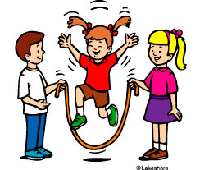D) Where is Spain?

8. ***They like __________________ .***

A) flying kites.

B) skipping rope.

C) coloring books.

D) swimming.

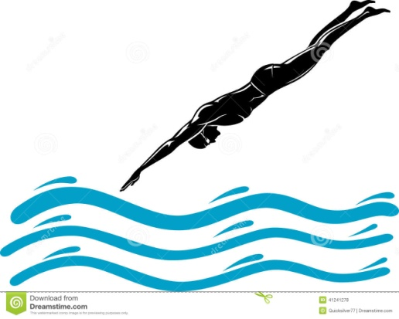9. ***He can _________________ .***

A) drive fast.

B) ride a bike.

C) doing puzzle.

D) dive.

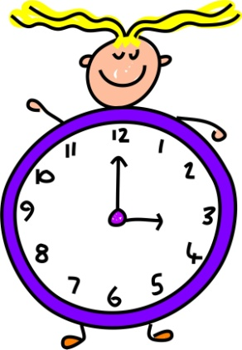**10. Yandaki görsele göre saat kaçtır ?**

A) It ‘s half past three.

B) It’s quarter past two.

C) It ‘s three o ‘clock.

D) It’s twenty to two.