1. 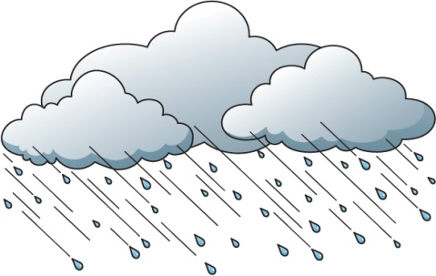Soruya verilebilecek cevap hangisi olmalıdır?

Anna: How do you feel on rainy days?

Robert:___________________________

1. It is hailing outside.
2. I feel upset and sleepy.
3. It’s cold and freezing.
4. I like sunny days.
5. İfadeyi hangi seçenek doğru tanımlar?

Autumn is my favourite season. I like _______

with my friends.

1. making snowman
2. swimming in the pool
3. go cycyling
4. walking in the rain
5. İfadede söylenmeyen yiyeceğin resmini bulunuz.

We eat croissant, fried eggs and toast in France.

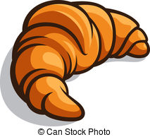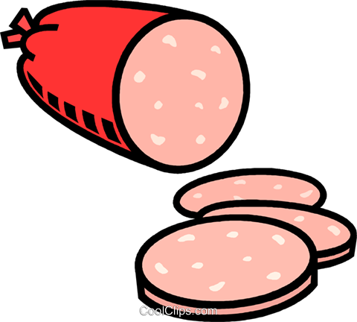

1. c)
2.  d) 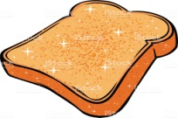

1. İfadeyi hangi seçenek doğru tanımlar.

I am in hurry. I have to go shopping to the ___________.

1. downtown
2. village
3. hometown
4. pharmacy
5. **Alice** : How many lemons do you want?  
   **Candy** : I want .....................................   
     
   **A)** a bar of lemons   
   **B)** a bottle of lemonate  
   **C)** ten lemons  
   **D)** a piece of lemons
6. " I am red and delicious. I am round. You can eat me in salad.  
   I am very healthy and useful.’’  
   **Tarif edilen şey hangisidir?**  
   **A)** cucumber  
   **B)** grapes   
   **C)** strawberry  
   **D)** tomato
7. İfadeyi hangi seçenek doğru tanımlar?

**CHILD** : I am hungry, Mom. Do we have ................ saugages?  
**MOTHER** : No, we haven’t got ........... . We have ........ eggs.   
  
**A)** an - any - any   
**B)** some- any- some   
**C)** a - some - any   
**D)** any - any – some

1. I think ...................... are fantastic.   
   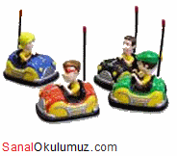  
   **A)** Carrousel   
   **B)** Wave swinger   
   **C)** Bumper cars   
   **D)** Big Wheel
2. Aşağıdaki soruyu resme göre cevaplayınız.  
   

**He feels ..................... .**  
**A)** bored   
**B)** excited   
**C)** nervous   
**D)** amazed

1. It is always warm or hot in Cairo. There are only two seasons. Summer is from May to October and it is always very hot – sometimes 35 degrees Celcius or 40 degrees Celcius. Winter is from November to April and in the day time it is nice and warm – usually between 18 degrees Celcius and 24 degrees Celcius. But it is sometimes very cold at night.

**Yukarıdaki paragrafa göre aşağıdakilerden hangisi yanlıştır?**   
  
**A)** It is very hot in May in Cairo.   
**B)** Winter is from November to April.   
**C)** There are four seasons in Cairo.   
**D)** It is between18 degrees Celcius and 24 degrees Celcius in Cairo