

**WOPENGLISH**

**9. SINIFLAR - KAZANIM TESTİ 1**

1. **Diyalogda boş bırakılan yere uygun düşen ifade aşağıdakilerden hangisidir?**

**A: _________ ?**

**B: Yes, I am.**

1. **Where are you from?**
2. **Are you British?**
3. **How are you**
4. **How old are you?**
5. **Aşağıdakilerden hangisi yanlıştır ?**
6. **Have you got a brother?**
7. **They are my friends.**
8. **He have got a dog.**
9. **We have got 2 uncles.**
10. **Aşağıda verilen saatlerden hangisi cümlede söylenen saattir?**

**“It is twenty five past eleven”**

1. 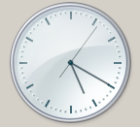 **B)** 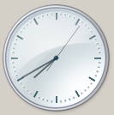

**C) 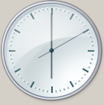 D)** 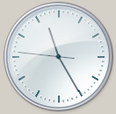

1. **Choose the correct choice for the blank in the sentence.**

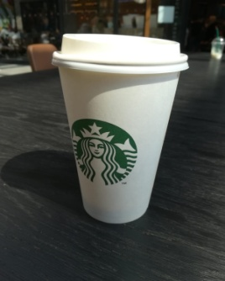

1. **Coffee cup is on the table.**
2. **Coffee cup is under the table.**
3. **Coffee cup is near the table.**
4. **Coffee cup is next to the table**
5. **Aşağıda verilen konuşmadaki bilgileri okuyunuz. Buna göre yanlış olan seçeneği işaretleyiniz.**

**“Hi. I am Jane. I am twenty three years old. I don’t have a big family. I have got one sister, but I haven’t got a brother. My mother is a doctor and her name is Jude. She is fifty years old. My father is a dentist and he is fifty five years old. His name is Jonathan. My sister’s name is Alex, and she is a student like me. She is twenty one years old.”**

1. **Jane is elder sister.**
2. **Jonathan is a doctor.**
3. **Jonathan is 55 years old.**
4. **Jude is fifty years od and is Jane’s sister.**